Using DEX Cloud – General

Updated October 24, 2023
Disclaimer
- This document describes DEX Cloud as of October 2023. Ongoing improvements and modifications to DEX Cloud may result in some discrepancies between this document and current implementation.
- Screenshots are taken from developer instances of the DEX Cloud generic Base profile or Texas implementation, using anonymized test databases, generally from previous years.
  - This will result in some minor discrepancies between screenshots and typical customer instances, such as resources displayed, school year, number of profiles, etc.
  - While test databases have been anonymized, some numeric identifiers might have been overlooked. For this reason, all numeric identifiers have been redacted in the screenshots.

Contents
Prerequisites 2
Initial Configuration 3
Preparation for Publishing 8
Publishing Data 19
Reviewing Data 24
Initial Data Synchronization 30
Troubleshooting Common Errors and Dependencies 35
Appendix A – Dashboard Resource Names 37
Appendix B – Ed-Fi Response Codes 40
Appendix C – Mapping Page Local Code Sources 41
Appendix D – Using Swagger 42

Prerequisites
Prior to following the guidance in this document, the following steps should already have been completed:
- Replication is set up and working. District IT department coordinates with PowerSchool CloudOps to accomplish this.
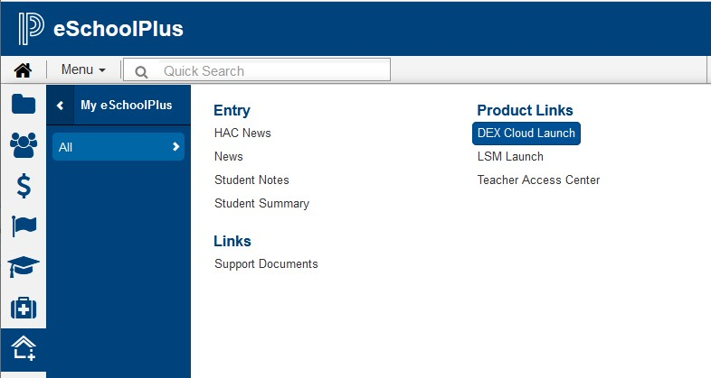
- DEX Cloud link is visible in the UI for authorized users (eSchoolPlus shown, display differs by product).

- Data Exchange and Authentication URLs have been obtained.
- Ed-Fi Key and Secret have been obtained.
Once you have a key and secret and have the DEX Cloud link available with database replication working, you are ready to configure DEX Cloud and get started with Ed-Fi.

Initial Configuration
- Launch DEX Cloud from SIS – DEX Cloud opens in new tab.
  - Known issue: DEX UI will timeout in approximately one hour, regardless of user activity.
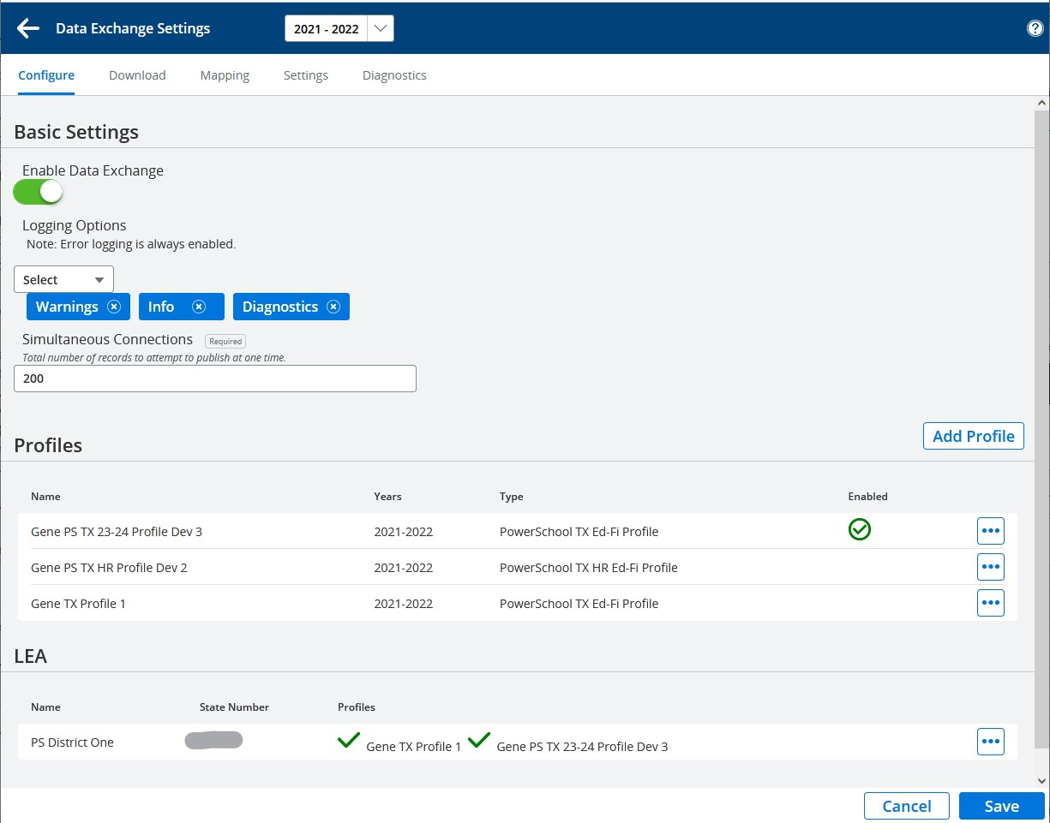
  - For initial setup, DEX opens on the Configuration page:
    - ‘Data Exchange Settings’ is displayed at top left of page.
    - ‘Configure’ is highlighted underneath ‘Data Exchange Settings.’
  - If not on the Configuration page, click gear icon at top right to display the Configuration page.
    - Applies to districts with prior DEX setup.
    - If you have an existing profile that is not current, DEX may display the Dashboard header with an error message. Clicking the gear icon will display the Configuration page, where you can update the profile.
  - Configuration page has three main areas: Basic Settings, Profiles, LEA
- Basic Settings
  - Enable Data Exchange – turn ON
  - Logging Options – additional selections not generally needed; default Error logging is sufficient.
  - Simultaneous Connections – 200 is a good initial setting (20 to 500 acceptable).
    - Setting too low results in poor publishing performance.
    - Setting too high results in frequent publishing errors (error ‘500’).
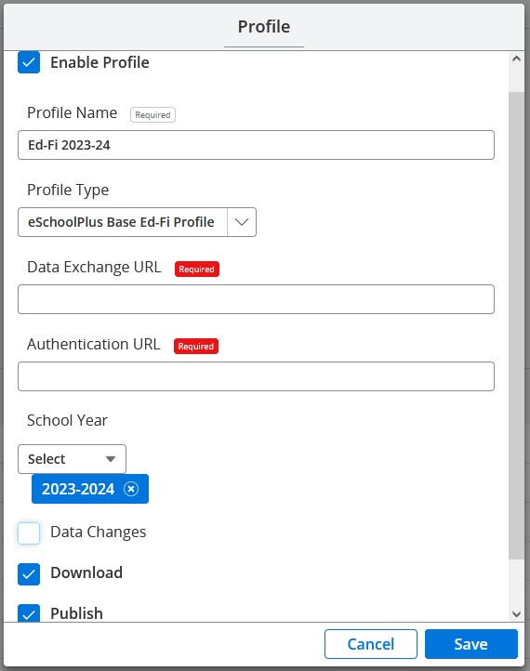
- Profiles – Districts may elect to reuse an existing profile if available; if so, click three dots to right of profile name and select ‘Edit’. Otherwise, click ‘Add Profile’ on right side of screen to display the Profile pop-up dialog:
  - Enable Profile – check to enable.
  - Profile Name – Profile name that will display in your DEX UI, e.g., ‘Ed-Fi 2023-24’.
    - Maximum 100 characters, but short name is recommended.
    - If you have multiple profiles, create a name that will distinguish this one from others.
  - Profile Type – select the type of profile you are adding.
    - For state implementations you would normally see an option that includes the state identifier, such as ‘Delaware Ed-Fi Profile’.
    - For district implementations you would normally select the option, ‘eSchoolPlus Base Ed-Fi Profile’.
    - You cannot change the profile type after saving, it is not included on the Edit dialog.
  - Enter the Data Exchange URL and the Authentication URL.
    - Districts reusing an existing profile will need to verify URLs and update if necessary.
  - Select the school year.
    - Multiple school years may be selected for a profile.
    - These school years are years for which the profile is valid.
    - Multiple school years do not mean that data must be published for each valid school year but it is recommended to only include school years for which you intend to publish data.
  - Check publishing options as desired:
    - Data Changes
      - Data changes made in the SIS or HR system are automatically published in near-real-time and/or weekday nightly process.
      - Recommend leaving unchecked during initial setup and publishing for school year.
    - Download
      - Required to download pre-loaded data from the ODS, which will be needed to enable publishing from your local data source.
        - Always includes code sets.
        - State implementations may include LEAs, schools, courses, etc.
      - Downloads are excluded from automatic publishing and are always user-initiated.
    - Publish
      - Required to publish data.
      - Includes weekend update process, which republishes all changes.
      - Uncheck only if you need to stop all publishing activity.
    - Note that the weekday nightly publishing is enabled or disabled as part of ‘Data Changes’, while the weekend publishing is independent from it.
  - Click ‘Save’ at bottom right of pop-up.
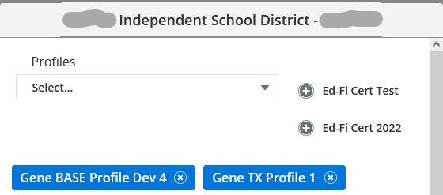
- LEA – Initially blank, automatically populated when profile is created. Provides connection setup for all profiles defined for LEA. Click 3 dots on right and select ‘Edit’, displays LEA profile connection dialog:
  - District name is header, with profiles defined for district shown in upper part of dialog pop-up.
    - The ‘Select’ dropdown is inactive – ignore it.
    - Profiles with no connection data are displayed at right with ‘+’ on left of profile name.
    - Profiles with connection data are displayed on blue background with ‘x’ on right of profile name.
      - The ‘x’ on the right is for removing the profile relationship.
      - A panel with previously entered data is displayed below for each profile with blue background.
  - Select a profile for setting up connection:
    - Click ‘+’ next to the profile name to open a new connection panel for profiles with no previous connection data.
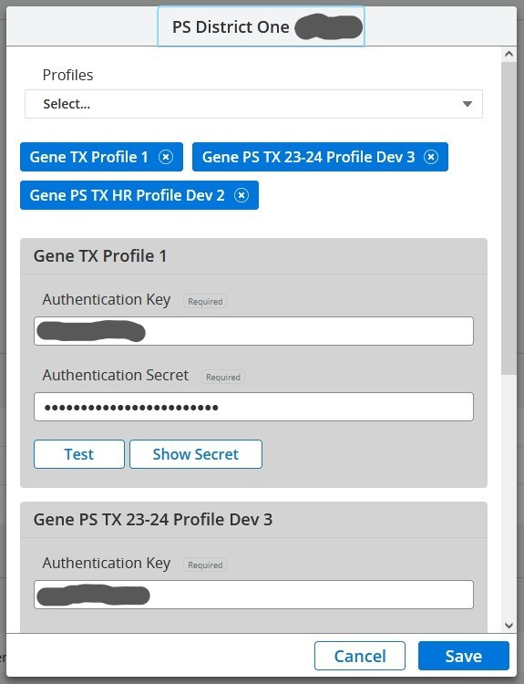
    - Scroll down to the existing connection panel for profiles with previously entered connection data.
  - Enter Authentication Key and Secret.
    - Districts reusing an existing profile will need to enter new key and secret if these have changed.
  - Click ‘Test’
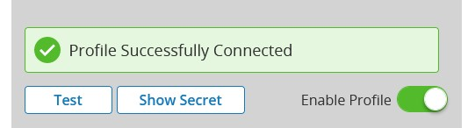
    - Should get ‘Profile Successfully Connected’ message with ‘Enable Profile’ switch.
      - Enable Profile.
        - ‘Enable Profile’ switch only appears after successful test.
        - Caution: important step, easy to overlook.
    - If test not successful, verify URLs, key, and secret, check for leading/trailing spaces.
    - If still not successful, contact agency that provided credentials or vendor Support.
  - Click ‘Save’.
- Click ‘Save’ at bottom right of Configuration page.
  - Publishing Dashboard for configured profile is displayed.
  - Name of profile at upper left.
  - Publishing groups, categories, and resources are displayed, described below under ‘Publishing Data’.
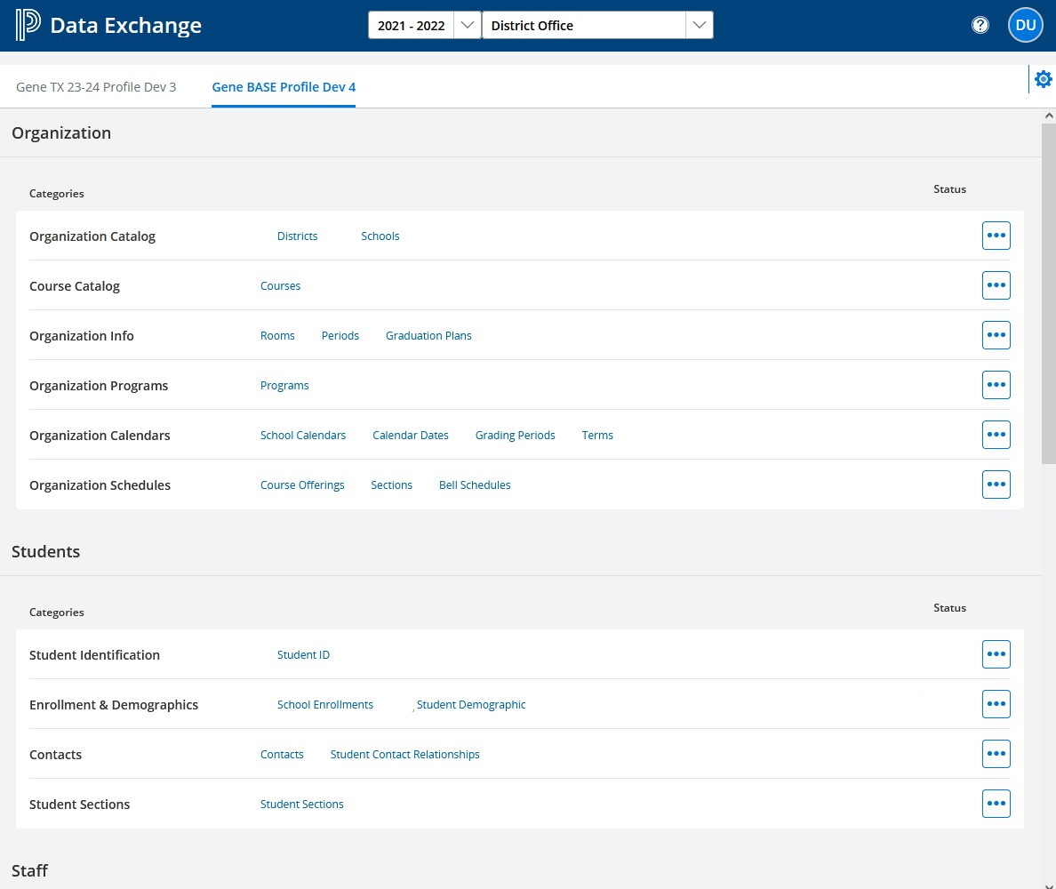
- With a profile defined, when you launch DEX Cloud it will open on the publishing Dashboard as the landing page.
  - This page will be explained later in the section on Publishing Data.
  - Note the gear icon at the top right of the page.
After completing initial configuration there are additional setup steps that need to be completed before you can begin publishing.

Preparation for Publishing
- Download Data – On the publishing Dashboard, click the gear icon at the upper right to access the Configuration page.
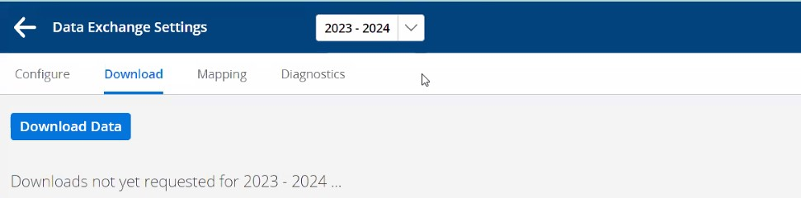
  - Select ‘Download’ from top of page – a ‘Download’ button is displayed alone if downloads have not previously been initiated. If they have, one or more panels will follow (described below).
  - Click the ‘Download’ button to initiate downloading data from the ODS.
    - DEX will search for resources pre-loaded into the ODS for download.
      - Resources to be downloaded are specified in the selected profile type.
      - All implementations will include descriptors, which are code sets. These will include state-defined codes, core Ed-Fi values, or a mix of both.
      - State implementations will often include LEAs, schools, courses, and/or programs.
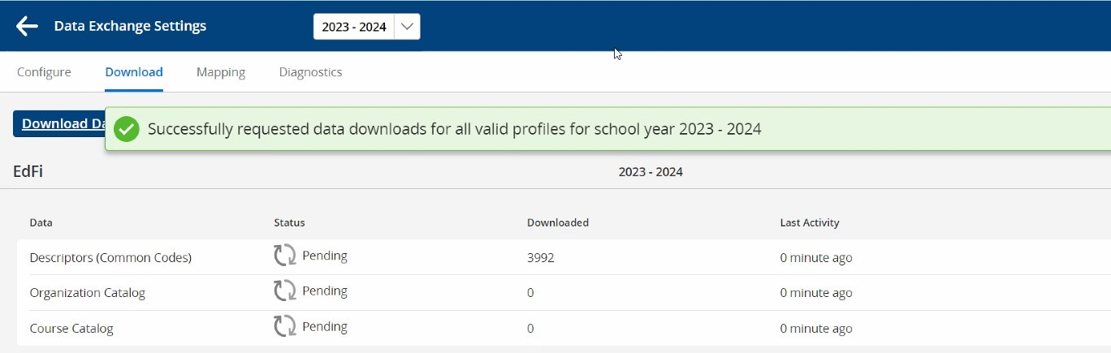
    - These pre-loaded resources are then displayed on the Download page and downloading is initiated.
    - After a few minutes the ‘Downloaded’ column will start displaying an increasing count of downloaded records for each resource.
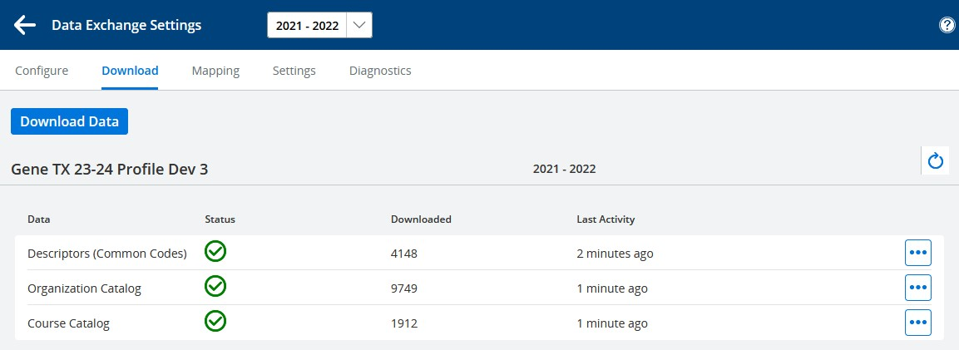
    - When completed, a green checkbox will be displayed in the ‘Status’ column.
  - A separate Download panel is displayed for each active profile.
  - Each Download panel includes the profile name and resources available for downloading in that profile.
  - Downloads can be updated manually at any time as described below.
  - Downloaded data is stored by profile and school year, so downloads must be done separately for each school year that a profile is used, if the profile is valid for more than one school year.
    - Districts reusing an existing profile will need to download data for 2023-24.
    - The school year is selected in the dropdown at the top of the page.
  - Typical Downloaded Resources:
    - Descriptors (Common Codes)
      - Descriptors are code values, such as Exit codes or Attendance codes.
        - Most states have defined codes for state reporting use, usually corresponding to legacy reporting code values.
          - These codes must be downloaded, if applicable, so they can be used in publishing data required by the state.
        - Ed-Fi includes core default codes independent of state codes.
          - These codes may be used in state reporting or may apply to data that is not reported to the state. If available, they are also downloaded so they can be used where corresponding state codes have not been defined.
      - To download, click the three dots at right and select ‘Download’.
      - After a few minutes the ‘Downloaded’ column will start displaying an increasing count of downloaded descriptor values.
    - Organization Catalog
      - When available, includes all Local Education Agencies and Schools recognized by state.
        - Basic identifying data is downloaded.
        - If not available for download, districts will publish LEAs and schools referenced in their local data.
      - To download, click the three dots at right and select ‘Download’.
        - This can be selected before descriptors have completed downloading. It will be in waiting status until the prior download job is completed, then it will begin.
    - Course Catalog
      - When available, includes all courses defined by the state.
        - Does not include locally-defined courses with no state course code.
        - Needed to publish Course-related data.
          - If not available, districts will publish courses in their local course catalog.
      - To download, click the three dots at right and select ‘Download’.
        - This can be selected before other downloads are completed. It will be in waiting status until prior downloads have completed, then it will begin.
    - Programs (not in screenshot)
      - When available, includes all programs recognized by the state, sometimes limited to those authorized within the district.
        - Needed to publish student enrollment in programs.
          - If not available, districts will publish programs for which they want to publish student data.
  - Reviewing downloaded data
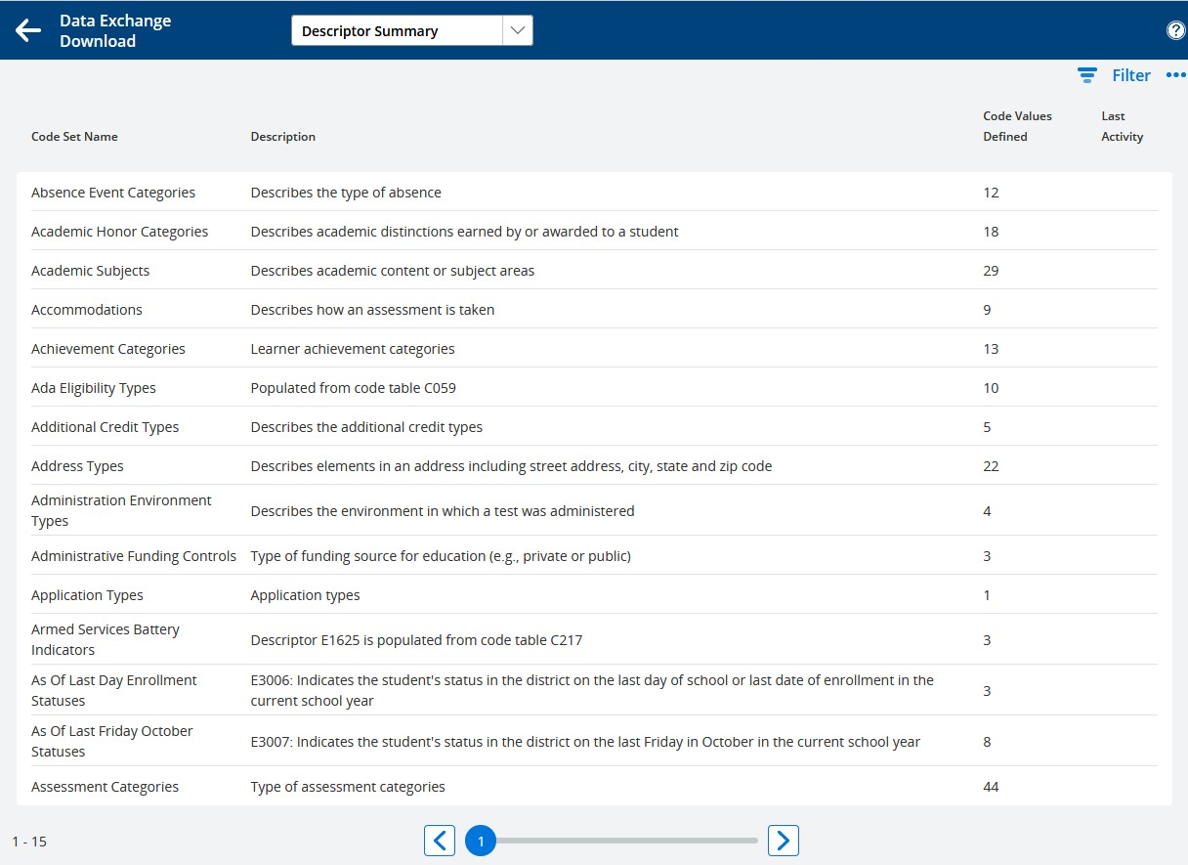
    - To review downloaded data, click the three dots on the right and select ‘Details’.
      - Descriptors – Details will display downloaded Code Set Names, with number of values defined for each code set:
        - Page through the list using the paging scroll at the bottom of the page.
        - ‘Descriptor Summary’ is displayed in a drop-down menu at the top of the page.
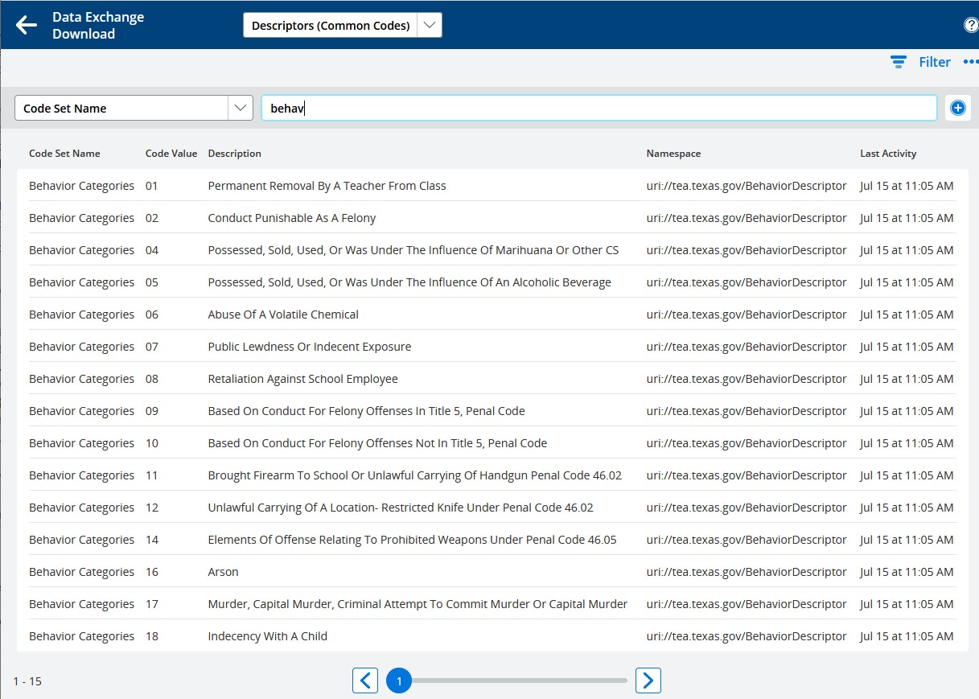
        - To see descriptor values, select ‘Descriptors (Common Codes)’ from the drop-down menu.
          - Filter the list by clicking on ‘Filter’ at the top right.
            - Select ‘Code Set Name’ on the left.
            - Begin typing the name of the code set you want, e.g. ‘Behavior’.
          - In many cases the list includes two different namespaces for the same code set.
            - uri://ed-fi.org indicates core Ed-Fi descriptors that will be recognized by the ODS but not always by the state.
            - Descriptors defined by the state will have a namespace that includes a state identifier, e.g. uri://tea.texas.gov/ (as in screenshot above).
        - Return to the Download page by clicking the left arrow at the top of the page.
      - Organization Catalog – Details will display the downloaded LEAs and schools.
        - List only – there is no lower-level detail view.
        - The list can be filtered by District Name, LEA ID, School Name, or State School ID.
      - Course Catalog will display the downloaded courses and (later) any additional courses that have been published by the district, where both course downloads and publishing are supported.
        - List only – there is no lower-level detail view.
        - The list can be filtered by State Course Code, State Course Title, or LEA ID (typically ‘1’ for all state-downloaded courses).
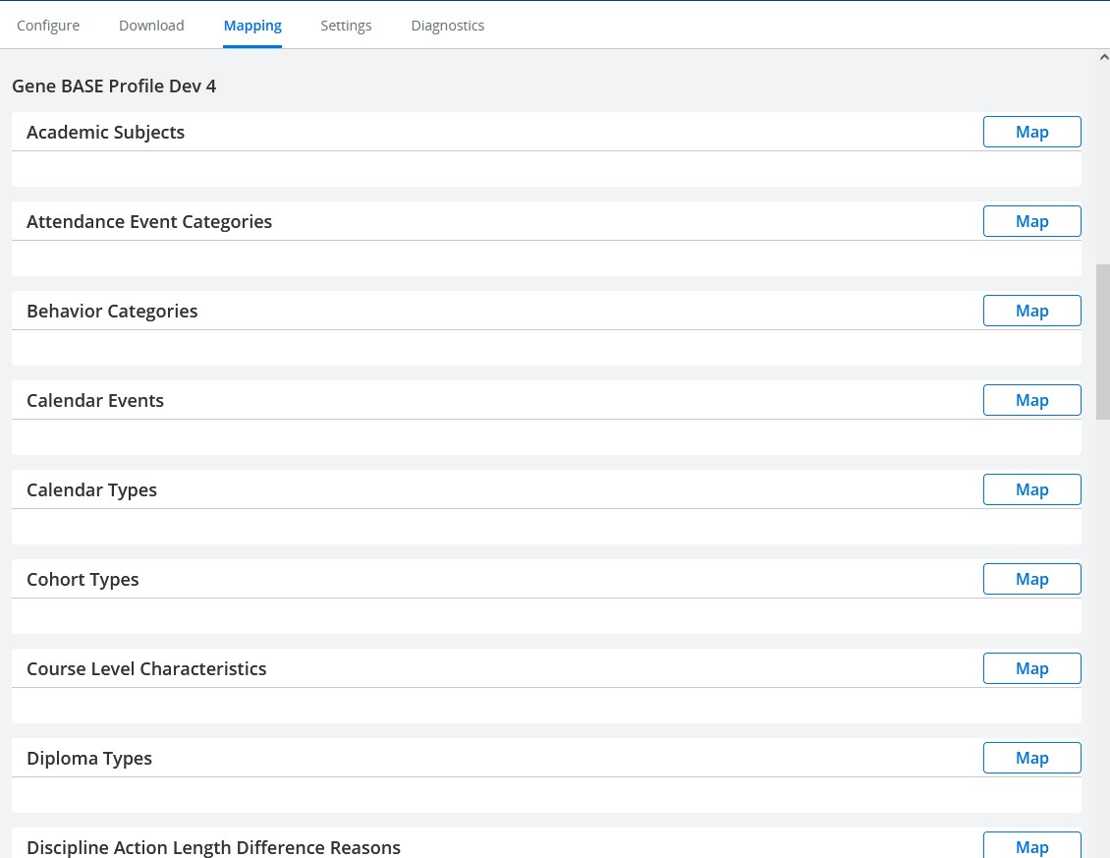
- Code Set Mapping – Select ‘Mapping’ at the top of the Configuration page to display the Code Set Mapping page. If returning to DEX or otherwise on the Dashboard page, click the gear icon at the upper right to access the Configuration page, then select ‘Mapping’.

  - The Mapping page includes a list of code sets on the left and ‘Map’ icons on the right.
  - There is a separate mapping panel for each profile, with the profile name as a header.
  - Use this page to map local codes to downloaded Ed-Fi code values.
  - In some cases, mapping selects which records to publish; these are noted below.
    - Example: if an Activity_Code is mapped to a Cohort Type it will be published, otherwise not.
  - Not all code sets are available for mapping, only those displayed on the page.
  - State implementations will often use STATE_CODE_EQUIV values in lieu of mapping.
  - District implementations will usually include the following mappings:
    - Academic Subjects
    - Attendance Event Categories – only absences and tardies are published; positive attendance is not published.
    - Behavior Categories – mapping selects which incident behaviors to publish.
    - Calendar Events
    - Calendar Types
    - Cohort Types – mapping selects which student activities to publish.
    - Course Level
    - Diploma Types – mapping selects which diploma types to publish.
    - Discipline Action Length Difference Reasons
    - Disciplines – mapping selects which incident actions to publish.
    - Educational Environments
    - Entry Codes
    - Exit Withdraw Codes
    - Grade Levels
    - Grade Types
    - Grading Periods
    - Graduation Plan Codes
    - Homeless Primary Nighttime Residences
    - Incident Location Types
    - Languages
    - Program Resources – map programs to resource for publishing, defaults to generic StudentProgramAssociation.
    - Program Types – mapping selects which programs to publish.
    - Race Types
    - Relation Types
    - Residency Status Indicators
    - School Categories
    - School Food Service Program Services
    - Telephone Number Types
    - Weapons
    - Attendance Types – select which attendance VIEW_TYPE to publish.
    - GPA Types – select which GPA type to use in Transcripts.
    - Excluded Reporting Terms – used in Grades, mapping optional.
  - To map a code set, click ‘Map’ on the right opposite the code set name.
    - In most cases a ‘District’ button will appear under the code set name.
    - A few code sets are mapped per school rather than district wide.
      - These will have a button for each school rather than a single ‘District’ button.
      - All the necessary code sets are district wide.
    - Click ‘District’ or (where mapping is by school) the name of a school.
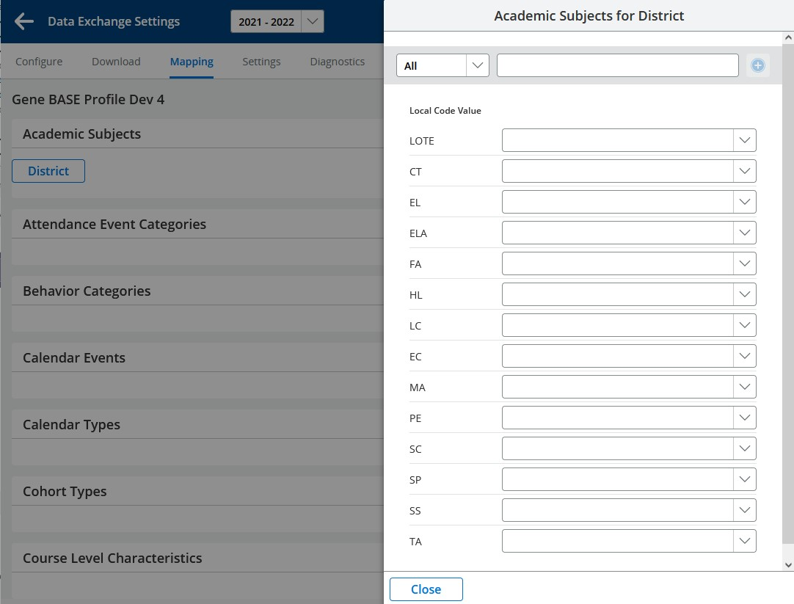
    - The mapping dialog for the code set appears on the right side of the screen:
      - The two boxes across the top are used for filtering the list.
        - Begin typing the desired local code in the box on the right – the displayed list is limited to codes containing what you typed.
        - To return to the full list, select ‘All’ in the drop-down menu on the left.
      - Below the top filter boxes, the mapping screen shows local code values on the left and mapped value selection dropdowns on the right.
      - Where local code values match downloaded values, these will be pre-mapped automatically.
        - Uncommon in district implementations, typically limited to state implementations.
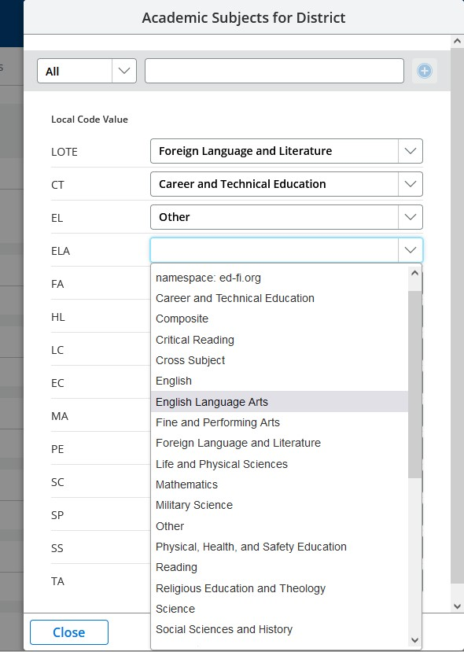
      - To map a local code, click the down arrow on the dropdown box to display downloaded values for that code set and select the desired value.
        - Values are listed by namespace, which indicates the source of the downloaded value.
          - Core Ed-Fi values are listed first, under the header, ‘namespace: ed-fi.org’.
          - State values (if applicable) are listed under a state header, e.g., ‘namespace: tea.texas.gov’.
        - Local code values that are not in use may be left un-mapped.
          - Un-mapped local codes encountered during publishing will result in an error.
        - Mappings are automatically stored as each code is mapped.
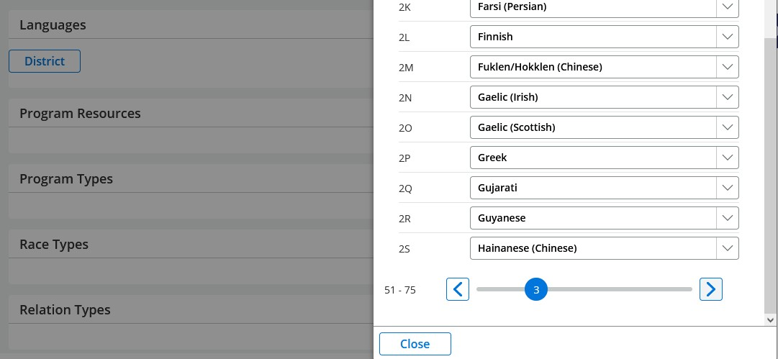
        - Longer lists of local codes require multiple pages, accessed via a pager at the bottom of the mapping dialog.
          - Known issue: when paging between multiple pages of codes, the UI may fail to display mappings that were completed during the current session on a previous page.
            - This is a display issue only, the mappings have been saved in the database
            - This can be verified by closing the dialog for the code set and re-selecting it again.
      - When all desired local codes have been mapped, click ‘Close’ at the bottom of the mapping dialog.
      - Code set mappings are stored by profile but not by school year, so mappings for a profile persist from one school year to another when the same profile is used for multiple years.
- Settings
  - Select ‘Settings’ at the top of the Configuration page.
  - The Settings page includes miscellaneous publishing options that must be completed for each active profile where relevant.
    - Settings options vary by profile. For most profiles the page will be blank or will contain only one setting option.
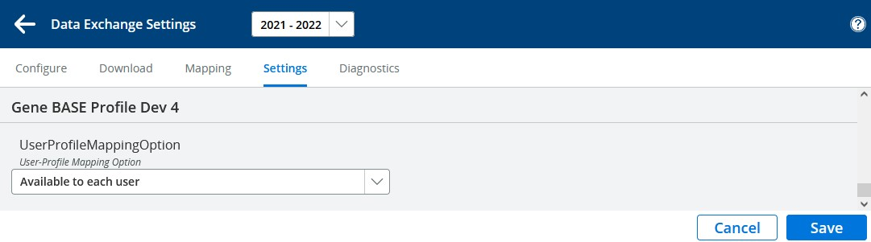
  - Each active profile has a separate Settings panel with the profile name as header:
    - UserProfileMappingOption – Security options for user access to profile data:
      - Available to each user – Profile is available to any DEX user.
        - Default setting.
      - Vendor-based authorization – In multiple-vendor implementations (e.g. separate SIS and HR system), users entering DEX from the SIS would see SIS data only and users entering from the HR system would see HR data only.
        - Currently multiple-vendor setup implemented only in Texas state profiles.
        - Affects only multiple-vendor implementations; no effect on single-vendor implementations.
      - Vendor- or user-authorization – Currently acts the same as Vendor-based authorization because user-based authorization is not yet implemented.
        - When user-based authorization is implemented, it will provide a way to define more precise access to each profile for each user.
    - Additional settings are planned. Some have already been implemented in Texas state profiles.
  - Click ‘Save’ when done.
    - After settings saved, need to return to Configure page then come back to Settings in order to re-enable ‘Save’
- Diagnostics
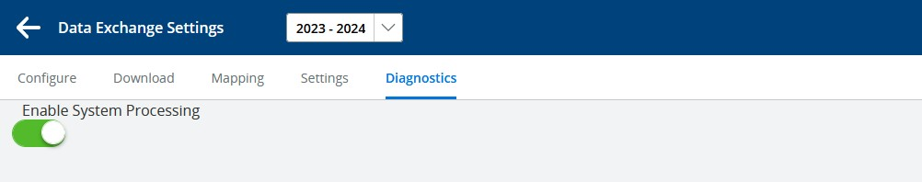
  - The Diagnostics page is not normally accessed. It is displayed when ‘Diagnostics’ is selected at the top of the Configuration page.
  - The Diagnostics page currently includes only a single ‘Enable System Processing’ switch, which should be set ON, as shown.
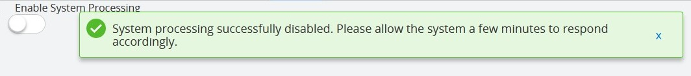
    - Setting ‘Enable System Processing’ OFF pauses the DEX background processing, which allows the system to resync and recreate potential missing internal indexes. Disabling takes one or two minutes.
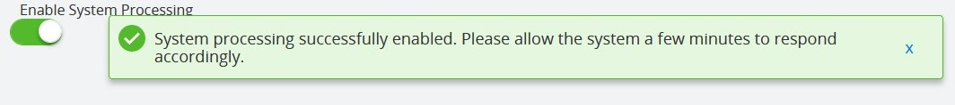
    - After disabling the system, it needs to be reenabled. This may require five to thirty minutes, depending on database size.
    - Disabling and reenabling the system might help if nothing is publishing or downloading.
      - Usually done only when directed by Customer Service.
Setup is complete. You are now ready to begin publishing your data.

Publishing Data
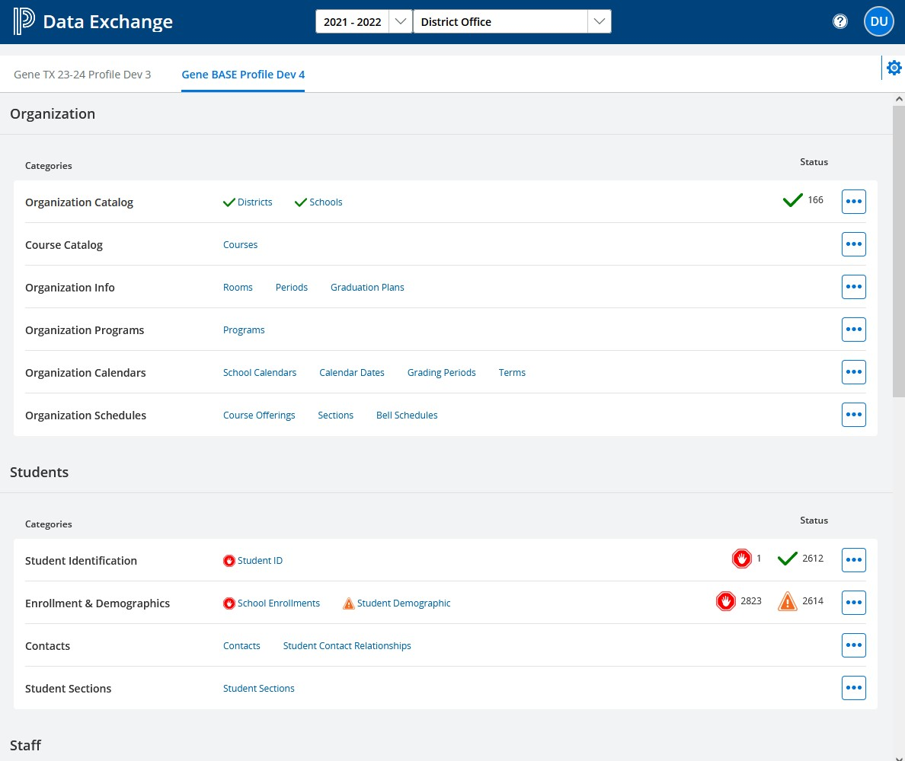
- The Dashboard. With a profile defined, DEX will automatically open on the Publishing Dashboard. If you are on one of the settings pages, click the left arrow at the top left to go to the Dashboard:
- After setup, the Dashboard is the main interface for using DEX.
- The Dashboard is displayed for the entire district by default.
  - ‘District Office’ is preselected in the top center dropdown menu.
  - Individual schools may be selected from the dropdown menu at the top, then the dashboard will publish and display only data for that school.
  - Internally, DEX processing is done by school. When ‘District Office’ is displayed, DEX processes records for each school in the district, one at a time.
- Dashboard Organization. The Dashboard displays all resources available for publishing, organized by Category and Data Group
  - Data groups (e.g. ‘Organization’, ‘Students’) are arbitrary large groupings of related data
    - They have no relationship to Ed-Fi or State standards but are for convenience in organizing the dashboard layout.
  - Categories are similar to Ed-Fi Domains or legacy Interchanges, with some modification to better facilitate publishing.
    - Categories are groupings of Resources (described below).
    - Categories are listed vertically, arranged top to bottom in the recommended order for initial publishing.
    - Publishing is done by Category – if you select a category to publish, all resources within that category are published if applicable.
      - Example: if ‘Organization Calendars’ is selected for publishing, the resources ‘School Calendars’, ‘Calendar Dates’, ‘Grading Periods’ and ‘Terms’ will all be published.
      - Individual resources cannot be selected for publishing.
    - In the screenshot, there are numbers and symbols in the ‘Status’ column for each category. These are added or updated during publishing and are explained below under ‘Publishing Status’.
    - The top two Categories shown (Organization Catalog and Course Catalog) plus ‘Organization Programs’ are district-level data and should be published from the district rather than from individual schools.
      - Other categories may be published at either the district level or at the individual school level.
  - Resources (also called ‘Entities’ or ‘End-points’) are the publishing units in Ed-fi. Data is published, updated, downloaded and/or deleted by resource.
    - Resource names and structure are defined in Swagger at https://api.ef-fi.org/.
      - See Appendix D – Using Swagger.
    - Resources are listed horizontally to the right of their respective category.
    - Resources are collections of related data elements, as specified in the Ed-Fi Data Standards, with additional extensions if defined by the state.
      - All data is published to the ODS using the specified resource for each data element.
      - Resources are displayed on the dashboard, but their elements are only displayed in detail views, described below in the ‘Reviewing Data’ section.
      - Within each resource, some elements are required by the Ed-Fi data standard.
        - The Ed-Fi API will return an error if required elements are missing or invalid.
        - Required Ed-Fi elements may or may not be required by a state.
        - State required elements may or may not be required for publishing.
          - States will typically run validation checks for missing or contradictory elements in data that was accepted by Ed-Fi for publishing but does not meet state requirements.
          - These checks are done within the state system but are not reflected in DEX Cloud.
        - Some of the Ed-Fi required elements are used to uniquely identify the record.
          - If two records have the same identifying elements, the ODS reads the second record as an update to the first, rather than retaining both as separate records.
          - In such cases, no error or warning is returned, since updating a record is a normal process.
    - In the screenshot, some resources have a check mark or other symbol in front of the name. These are added or updated during publishing and are described below under ‘Publishing Status’.
    - The resource names displayed on the dashboard are modified from the actual Ed-Fi API names used in publishing, to improve readability and understanding.
      - Examples: ‘Calendar Dates’ is displayed for Ed-Fi ‘calendarDates’, ‘School Enrollments’ for Ed-Fi ‘studentSchoolAssociations’.
      - A list of displayed resource names and their Ed-Fi API names is provided in Appendix A.
    - DEX maintains an internal record of all resources published, including element values.
      - Referred to as the ‘DEX Publishing Catalog’ or simply the ‘DEX Catalog’.
      - The DEX catalog is not visible to users but is key in processing data for publishing.
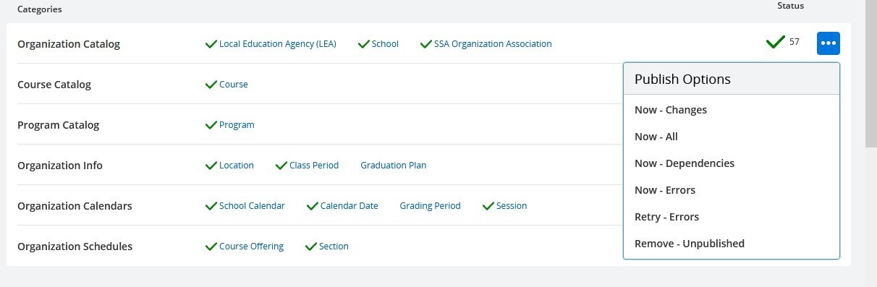
- Dashboard Controls. The Dashboard provides user controls for publishing data on demand. Publishing options are accessed by clicking the three dots to the right of the category:
  - Now – Changes. The default option: checks for differences between current values and what is in the DEX catalog for each resource in the category.
    - Use: If data has already been published for any resources in the category, this option should be used for on-demand publishing.
    - Records found that are not in the catalog are published.
    - Records found that are in the catalog but with data differences from the catalog are republished.
    - Records present in the catalog but no longer found in the data are deleted.
  - Now – All. Complete republishing of the category.
    - Use: If no data has been published in the category, this option should be used for initial publishing. Otherwise, it is not normally used.
    - All data in the category is published without checking for changes.
    - Records present in the catalog but no longer found in the data are deleted.
  - Now – Dependencies. Republishes records in the category that are in ‘Dependency’ status, explained below under ‘Publishing Status’.
    - Use: If the category has records in dependency, this option initiates publishing them on demand rather than waiting for the automatic dependency republishing, described below.
  - Now – Errors. Republishes records in ‘Error’ status after updating records.
    - Use: republish after modifying data to fix errors.
  - Retry – Errors. Republishes records in ‘Error’ status without updating.
    - Use: Republish when API returned ‘Unexpected Server Error’ (code 500), meaning that error was due to problem communicating with server, not in the data that was sent.
  - Remove – Unpublished. Removes records from catalog that have never been published.
    - Use: Remove unpublished records from the catalog when the issue is caused by a known problem that cannot be readily resolved.
    - Includes records in Dependency and Error status.
    - Subsequently selecting ‘Now – Changes’ or ‘Now – All’ will reinstate these records into the catalog.
- Automatic Publishing. In addition to user-selected publishing options on the dashboard, DEX also publishes data automatically.
  - If ‘Data Changes’ is selected for the Profile on the Configuration Page, then DEX will automatically publish changes made in the source system in near-real-time.
    - Some categories (e.g., Attendance) require substantial processing and for them, automatic publishing is done in the weekday nightly process.
    - Some categories may on occasion have an unusually large volume of changes, such as Student Sections during the first days of the term. DEX monitors this and if the volume is too high, automatic publishing for that category is temporarily moved to the weekday nightly process.
  - A weekend data synchronization process publishes changed data and updates the catalog, irrespective of whether ‘Data Changes’ has been selected.
  - After Initial Synchronization (explained below), it is recommended to update the Profile settings to include ‘Data Changes’ if it has not been previously selected. This will greatly reduce the need to publish from the dashboard going forward.
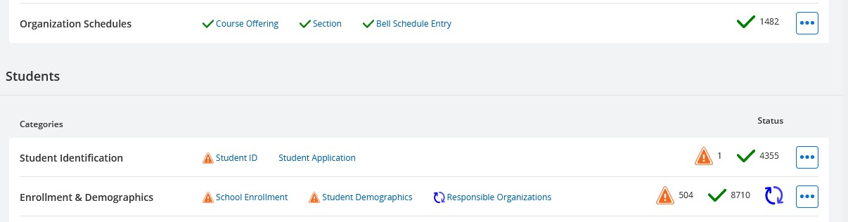
- Publishing Status. The Dashboard displays publishing status for categories and resources.
  - A green checkmark indicates that all records for the resource were published successfully.
  - An orange triangle indicates that one or more records had a dependency issue. Dependency issues are caused when one resource depends on the prior publication of another resource, or when a required element is missing in the data.
    - Resource dependency: ‘Calendar Dates’ includes a reference to ‘School Calendars’, so ‘School Calendars must be published first.
    - Element dependency: Student ID is missing the required element, e.g., StudentUniqueId.
    - The Ed-Fi API will return a dependency error (error code ‘403’) if a dependency condition is found.
    - During processing, DEX checks for possible dependency errors and withholds affected records from publishing.
      - Both types of dependency are flagged internally and indicated by the orange triangle.
      - The reason for dependency is displayed on the Details page, described below.
    - DEX will attempt to reverify or republish dependencies automatically with an increasing time interval between attempts.
        - For DEX-calculated dependencies, the initial interval between attempts is 1 minute.
        - For ‘403’ returned dependencies, the initial interval between attempts is 10 minutes.
        - After each attempt, the interval is increased by one minute until a maximum of 99 minutes.
      - Automatic republishing of dependencies is always active when publishing is enabled.
  - A red Stop sign indicates that one or more records had an error.
    - Errors may be caused by invalid data types, descriptor values, or other data issues that you will need to correct and then republish.
    - Errors may be caused by issues in data structure or other problems in the publishing process.
    - The error message returned by the Ed-Fi API is displayed on the Details page, described below.
    - Ed-Fi API error codes are listed in Appendix B.
  - ‘Waiting’ on the right side means that the category has been selected for processing by the user and is queued for processing.
    - Multiple categories can be selected for publishing. They will be put in waiting status and will be processed in the order they were selected.
    - The next category in the queue will not be started until the previous one has been completed.
  - Circling light grey arrows indicates that the resource is being processed for publishing.
  - Circling blue arrows indicates that the resource is currently being published.
  - When publishing is completed for a category, all applicable symbols are displayed, along with the total number of records for that were published, in dependency, or had errors.
  - No symbols displayed indicates that either no records were found for the resource, or that the category has not yet been published and is not in ‘Waiting’ status.

Reviewing Data
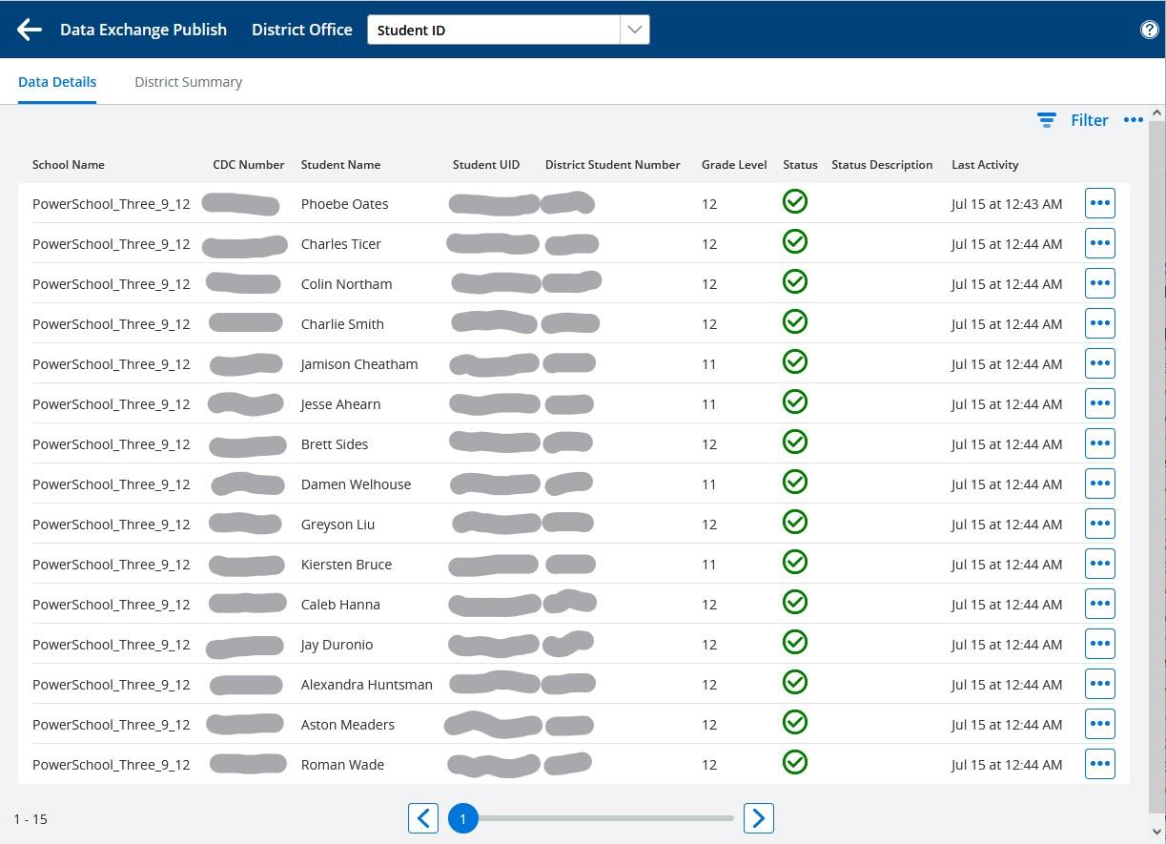
- To review data, click the name of a resource on the Dashboard to display a list of records that have been published or processed. For example, clicking on ‘Student ID’ displays the Data Details page for the resource, which is a list of all processed Student ID records:
  - ‘Data Exchange Publish’ with a left arrow is displayed at the top left of the page. Click the left arrow to return to the Dashboard.
  - ‘District Office’ is displayed next at the top of the page. It is the Dashboard context. If a school had been selected on the Dashboard, the school name would be displayed instead.
  - ‘Student ID’, the selected resource name for this list, is displayed next across the top of the page.
    - With the district context, all Student ID records in the district are included. If a school had been selected on the Dashboard, the list of records would be limited to those at the selected school.
    - List pages with the district context include the school name and CDC number.
    - List pages with a school context do not include identifying data for the school.
  - The right-most columns, showing status and activity information, are included on list pages for all resources.
  - Other columns will vary depending on the resource. Key elements and other elements helpful for identifying and troubleshooting data are included for each resource.
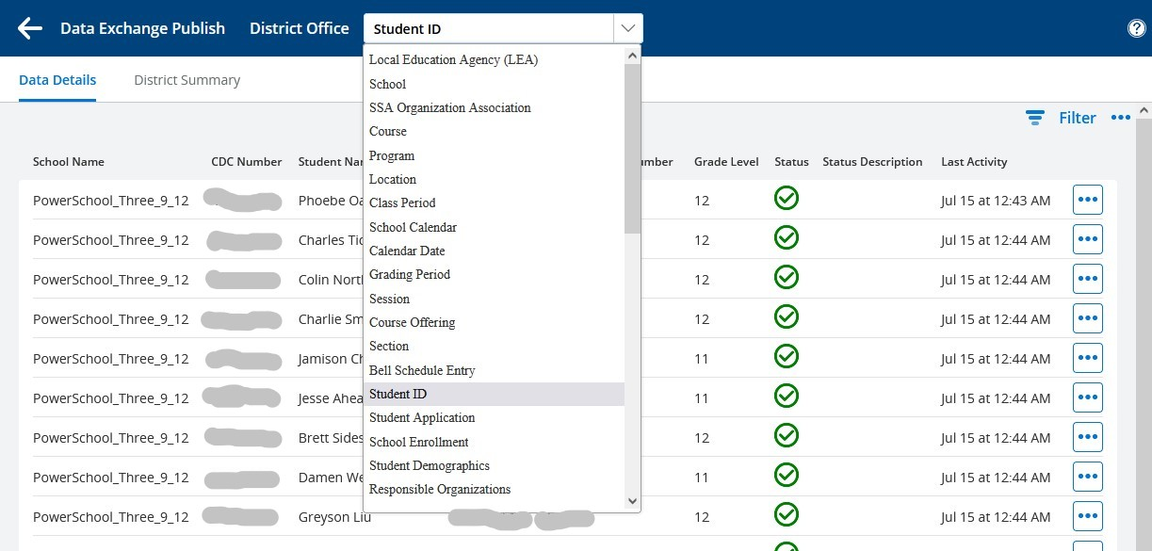
  - The resource name, ’Student ID’ is displayed in a dropdown menu. You can switch from one List page to another using this menu without returning to the Dashboard.
- Filtering Data
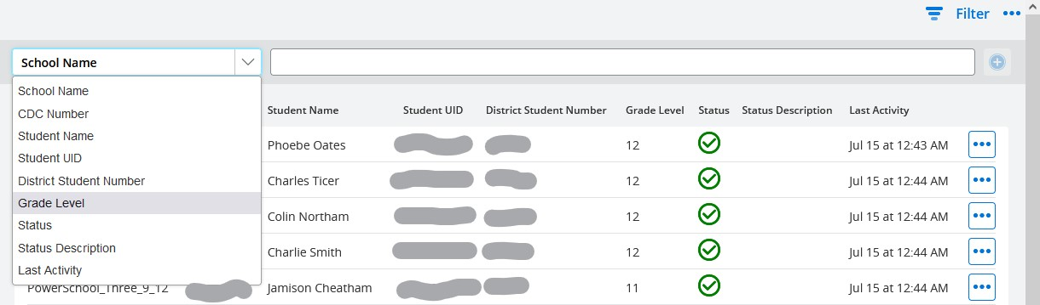
  - Every list page includes a filter at the top right of the page. You can filter on any of the columns displayed on the page. Clicking the ‘Filter’ icon displays the filtering options.
  - For example, selecting ‘Grade Level’ and then typing ‘12’ in the right-hand box will limit the selection to students in grade 12.
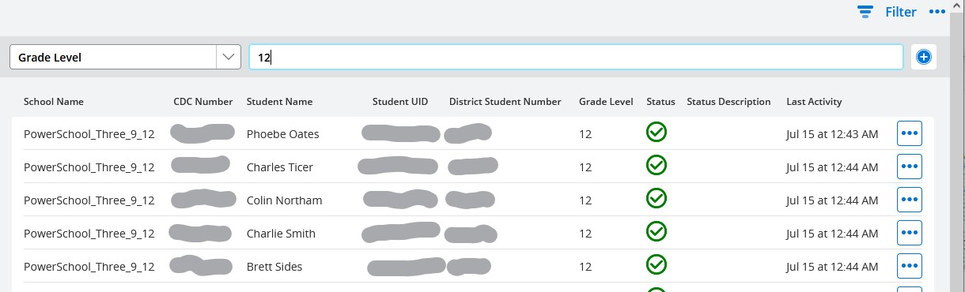
    - After selecting ‘Grade Level’ the page will refresh, then you will be able to type ‘12’ and the filtering will take effect.
  - With a filter selected, the ‘+’ sign to the right of the filter becomes active, allowing selection of an additional filter within the context of the first.
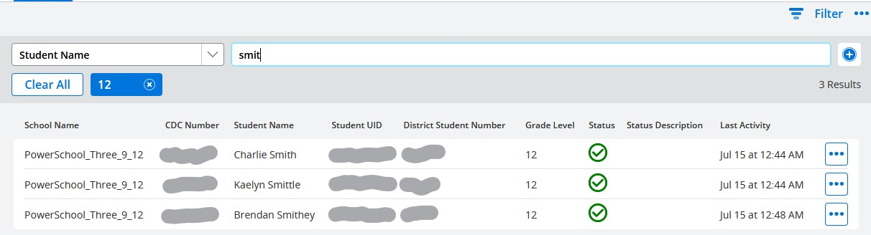
    - Example 1: After clicking the ‘+’, ‘Student Name’ was selected from the filter dropdown and after refreshing, ‘smit’ was typed into the filter box.
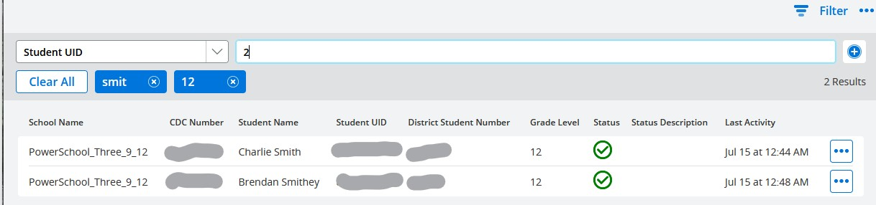
    - Example 2: The ‘+’ was clicked again, ‘Student UID’ was selected from the dropdown and ‘2’ was typed into the filter box.
      - Note that each previously entered filter is displayed in a blue box with the value entered and ‘x’ on the right.
      - Previously entered filters can be removed by clicking the ‘x’ on their respective blue box. Other filters will remain in place.
      - Clicking ‘Clear All’ will remove all filters, including the most recent one across the top of the page.
  - It is often helpful to limit the list to error or dependency records. From the Filter options, select ‘Status’.
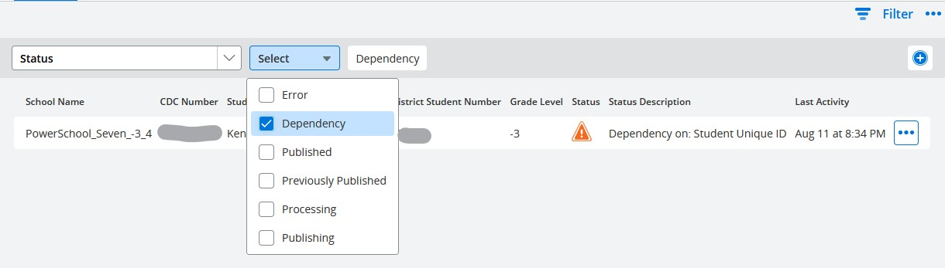
    - A dropdown menu will appear. Select the status you want to review.
    - Dependencies and errors will include the dependency reason or the returned error message under ‘Status Description’, if available.
    - Known issue: if you select more than one status option at a time, the filter may not act as expected. Typically, the last option selected will take precedence and others will be ignored.
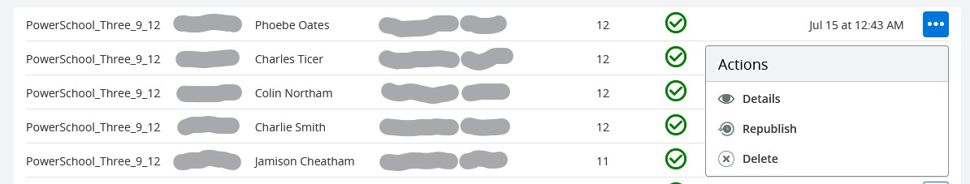
- Record Details – Clicking the three dots to the right of a record on any list page displays available actions.
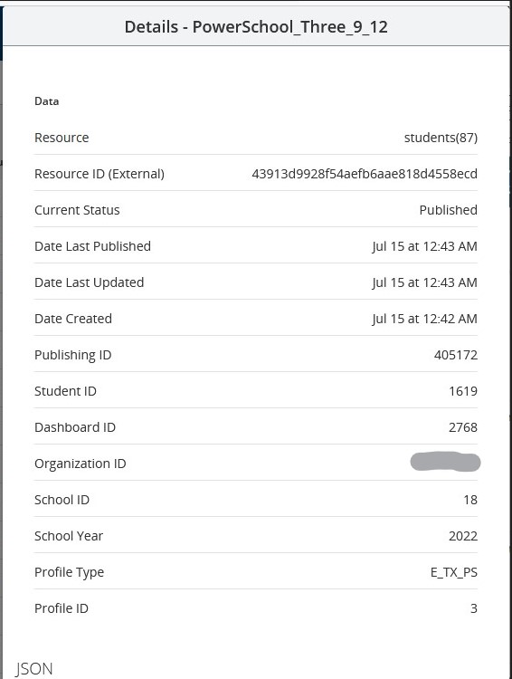
  - Details – displays publishing details, including the actual JSON sent to the ODS
    - Resource – the Resource name and DEX identifying code
    - Resource ID (External) – the GUID passed back from the ODS when the record has been successfully published.
    - Publishing ID, Dashboard ID, Profile ID – Internal DEX identifiers
    - Student ID – the internal SIS student record identifier, REG.STUDENT_GUID
    - Organization ID – the published school or district state identification number
    - School ID – the internal SIS record number for the school, REG_BUILDING.BUILDING
    - JSON – the full JSON content of the message sent to the ODS.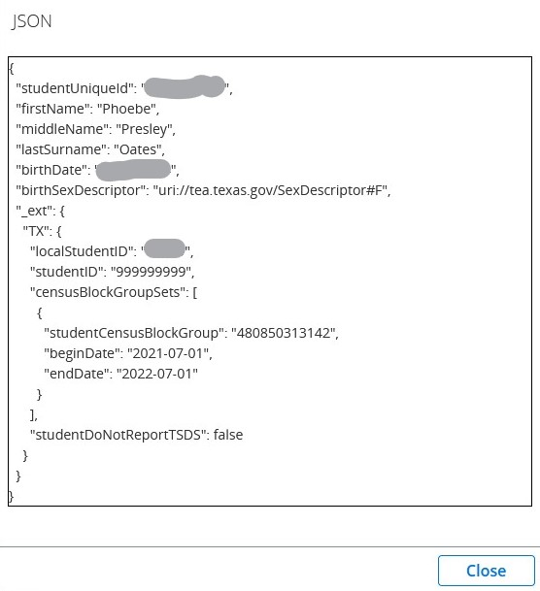
      - Not included for dependency records (JSON not constructed for records held in dependency).
      - Removed after a few days for error records. Can be reinstated by republishing single record or all error records for category.
    - Click ‘Close’ to return to list.
  - Republish – initializes republishing for single record.
  - Delete – Sends ‘Delete’ event to ODS for single record.
    - ‘Delete’ event is sent without any validation, so even if a record is valid, it will still be deleted.
    - Republishing changes for the category will republish the record if it is still valid.
    - Option rarely used, helpful for some intermittent scenarios or for testing purposes.

Initial Data Synchronization
- An initial data synchronization is necessary for DEX to recognize further changes as they take place and publish them to the ODS.
  - In theory the weekend process should be able to accomplish this initial publishing, but it is recommended to initiate synchronization manually from the dashboard.
    - Both setup and initial manual publishing need to be accomplished in the same week.
      - There is only a one-week window for setup and initial synchronization under user control, so setup and manual synchronization should be started early in the week where possible.
      - The first Saturday night after setup, the weekend processing will initiate everything automatically and users will no longer have control over any remaining initial synchronization.
    - While multiple categories may be initiated simultaneously, where practical it is recommended to wait for each category to complete before starting the next. This will help resolve dependencies within a category that might affect a subsequent category and will improve overall performance of initial synchronization, especially for larger districts.
  - The dashboard is organized in an approximate recommended publishing sequence for this synchronization, top to bottom.
  - The following descriptions apply to SIS profile types (district or state). HR profile types include only the Staff categories indicated below plus Finance categories.
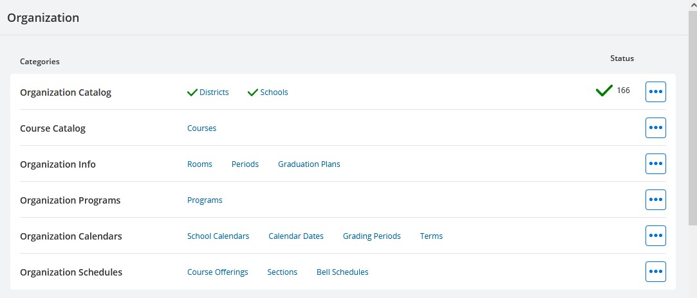
- Publish the categories under ‘Organization’ at the top of the Dashboard.
  - Start with the first category, ‘Organization Catalog’. The other categories are dependent on LEAs and Schools.
    - Initiate publishing by clicking the associated three dots on the right and selecting ‘Now – All’ (or ‘Now – Changes’ if some data has already been published in the category).
    - Then initiate publishing for the next three categories, ‘Course Catalog’, ‘Organization Info’ and ‘Organization Programs’.
  - The first two categories and Organization Programs should be published at the district level.
  - For all other categories you may choose to publish at the school level, especially if you are new to the system and want to try it out in a limited context.
  - Begin publishing for the remaining two Organization categories, in order. If you are continuing at the district level, you can select them before the previous ones have completed publishing.
    - Organization Info
      - Graduation Plan is published only if plans were mapped.
    - Organization Calendars
      - Depending on district setup, Grading Period records might not be published.
        - This resource is used only in publishing Grades, which is not collected by some states
        - Enable publishing by completing mapping for Grade Types, Grading Periods, and Excluded Reporting Terms.
    - Organization Schedules
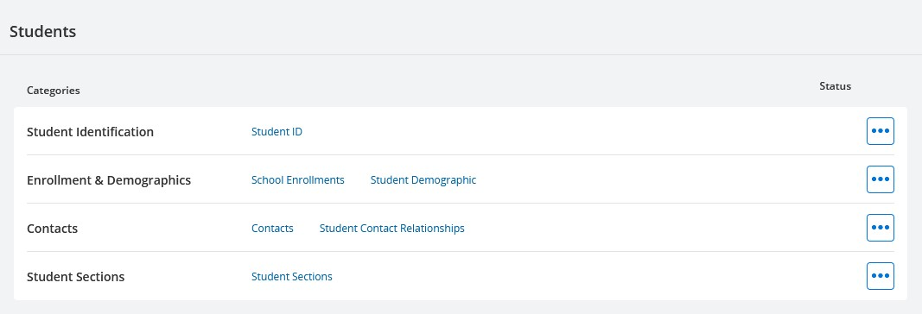
- Publish the categories under ‘Students’.
  - ‘Student Identification’ must be started first. This category has an unusual relationship with the second category, ‘Enrollment & Demographics’ because each ‘Student ID’ record can only be published once prior to publishing a ‘School Enrollment’ record for the student.
  - ‘Enrollment & Demographics’ should immediately follow ‘Student Identification’.
    - The ‘School Enrollment’ resource in this category establishes the relationship between the district and the student.
    - The resource ‘Student ID’ must be published first because ‘School Enrollment’ references both it and Schools.
    - However, to make any updates to ‘Student ID’ (including republishing without change), or to publish any other student data, the relationship must be established by publishing a ‘School Enrollment’ at a school within the district.
    - Expect to see dependencies appear on both resources, that will automatically clear out as synchronization continues.
  - Once ‘Student Identification’ and ‘Enrollment & Demographics’ have been initiated, the other categories in ‘Students’ may be started in any order.
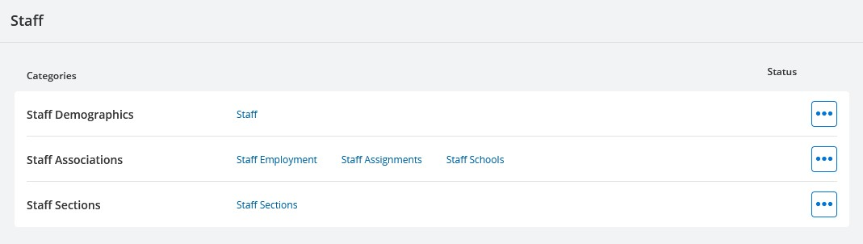
- Publish the categories under ‘Staff’.
  - Staff Demographics should be published first, followed by Staff Associations.
    - ‘Teacher’ Staff Assignment records are published for all staff who taught a course section during the selected year, whether or not they are active or indicated as Teachers in the SIS.
  - Staff Sections may be started before the other Staff categories have completed publishing.
    - Staff Sections are dependent on other Staff categories and on Sections, but they are independent of Student Sections.
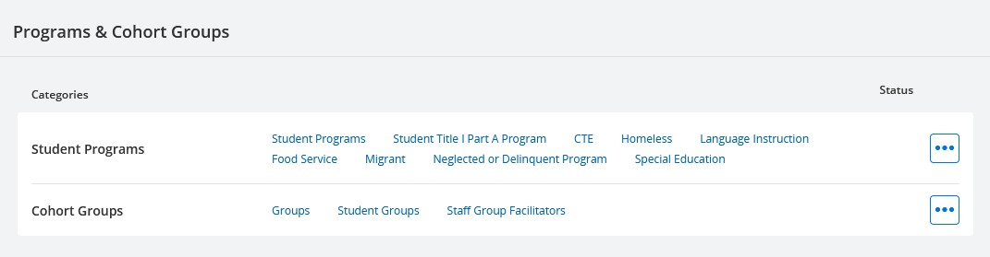
- Publish the categories under ‘Programs & Cohort Groups’.
  - The resources in the Programs category are not dependent on any Staff resources, only on Program Catalog, Student ID, and School Enrollments.
    - Not all Student Programs will be published for every district.
      - Programs must be either defined by the state and downloaded or mapped for publishing during DEX setup.
      - Only those Student Programs for which your district has data are published.
  - Cohort Groups
    - Not included in most state profiles.
    - Where implemented, includes only groups mapped to a Cohort Type in DEX setup.
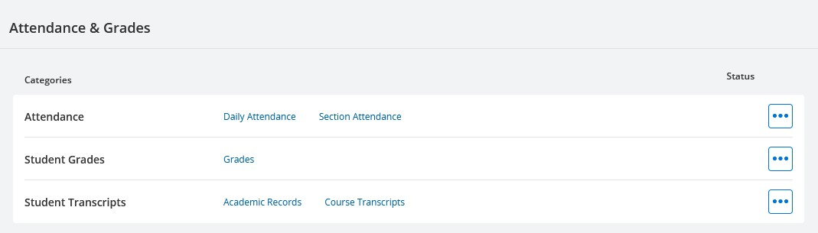
- Publish the categories under ‘Attendance & Grades’.
  - The categories in this section contain larger amounts of data with greater change rates than other categories. For this reason, they are not automatically published transactionally as changes happen (near real time) but are updated during the weekday nightly and weekend processing.
  - Attendance
    - May include Section Attendance in addition to Daily Attendance.
      - Publishing Section Attendance is determined by a back-end setting
      - The option to enable/disable Section Attendance will be added to the configuration settings.
    - The nightly process publishes changes for the last 14 days, the weekend process publishes all changes.
  - Student Grades
    - Publishing may be disabled by a back-end setting.
      - The option to enable/disable publishing grades will be added to the configuration settings.
    - The nightly process publishes missing records only, the weekend process publishes all changes.
    - Code set mapping related to grades is optional but may be needed to clear errors and dependencies.
  - Student Transcripts are collected by most states but not needed until later in the school year.
    - Includes graduation data for students graduating during the current school year and course completion data for the current school year.
    - The nightly process publishes missing records only, the weekend process publishes all changes.
    - Suggest skipping this section for initial synchronization if early in the school year.
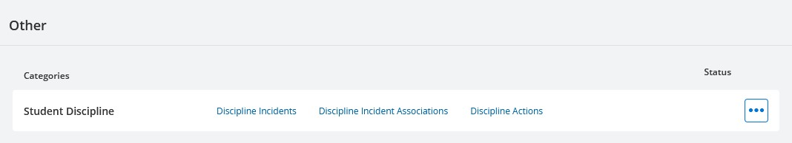
- Publish the categories under ‘Other’.
  - Student Discipline – dependent only on Student ID and School Enrollments.
  - Additional categories and resources may be included in state profiles.
    - Examples: Restrain Events, Medical
- When synchronization from the dashboard is completed, select the gear icon at the upper left to return to the Configuration page.
  - Under ‘Profiles’, click the three dots and select ‘Edit’.
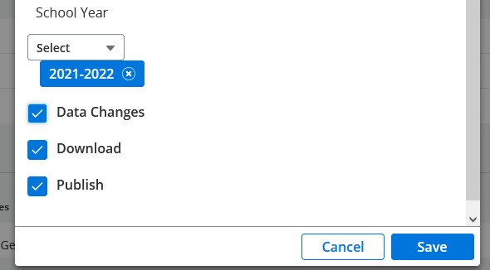
  - Check ‘Data Changes’ to enable automatic transactional processing and click ‘Save’.
  - Data changes will be published automatically, in near-real-time for most resources, otherwise in the weekday nightly process.
  - From here on, the Dashboard is principally a monitoring and debugging tool, not the primary means of initiating publishing.

Troubleshooting Common Errors and Dependencies
Adapted from PowerSchool SIS PSSR Ed-Fi, online guide.
Common Errors
Errors typically occur when data is being published to the ODS, but something happens in the transmission of the record and it is rejected on the ODS side. The categories on the Ed-Fi Dashboard are arranged such that errors on one line may propagate downward as dependencies. It is important that you always work from top to bottom when addressing issues. Records with dependencies or errors can be viewed clicking on the resource name to display the list page, then filtering on Status.
Below are some common errors that can occur and how to resolve them.
# | Message | Description
400 | Validation of 'XYZ' failed. StudentUniqueId/StaffUnqiueId is required. | This error can occur when there is a problem in the Ed-Fi system or when the Unique ID of the student or staff member has changed. If other data is publishing normally, then the Ed-Fi system is working correctly. Run ‘Now - Changes’ or ‘Now - Errors’ on the category.
409 | The value supplied for the related 'XYZ' resource does not exist. | This error occurs when DEX shows that the parent resource, XYZ, has been published, but the ODS does not have the record in its system. To resolve this issue, run ‘Now - All’ on the Category that contains the XYZ resource.
500 | An unexpected error occurred on the server. | This error is typically due to an issue on the ODS or state end. Retry publishing the record using ‘Now - Changes’, ‘Now - Errors’ or ‘Retry - Errors’. If this results in another 500 error, the state will need to be contacted to determine the issue on their end.
503 | Service Unavailable | This error is due to an issue on the ODS server where the Ed-Fi system is not running properly on the server. Contact the state with this error code. Once the state has resolved the issue, run ‘Now - Errors’ on the Dashboard.

Common Dependencies
Dependencies on a record are due to either 1) missing or invalid data, or 2) an unpublished reference record. For example, a student may be missing a Unique ID; this would cause their record to be in dependency. Another example would be a Student Section record trying to publish with a dependency on Section Record. This dependency can occur if the Student Section record has tried to publish before the Section record has been published.
Below are some common dependencies and their resolutions.
Dependency | Resolution
Student/Staff Unique ID | Record is missing the required State Assigned Unique ID. For states where the Unique ID can be requested on the student or staff page, select the request button and acquire the Unique ID. Otherwise, follow your state process for obtaining the Unique ID. Once a new ID is assigned, go to the Ed-Fi Dashboard and run ‘Now – Changes’ for the category. You can also publish the individual record from the resource’s List page.
Student School Association | A Student record cannot be updated and other student data cannot be published until the student record is claimed on the ODS side. To claim the record, a School Enrollment record (Student School Association) must be published. Start by running ‘Now - Changes’ on the Enrollment & Demographics category to publish the enrollment records. When School Enrollments have published, DEX will retry Student Demographics records still in dependency. For other student records, run ‘Now - Changes’ for the category.
Staff School Association | A Staff record cannot be updated and other staff data cannot be published until the staff record is claimed on the ODS side. To claim the record, a Staff Employment record or Staff Assignment record must be published. Start by running ‘Now - Changes’ on Staff Associations to publish the associations records. When Staff Associations have published, run ‘Now - Changes’ on Staff Demographics to retry the records.
Alternate Course Number not set | Either the Alternate Course Number has not been set on the Course, or the Alternate Course Number is not a valid state course number. Update the Alternate Course Number and run ‘Now - Changes’ on Organization Schedules.
Missing Section Meeting Record | The Section does not have a period selected. Add a period to the section and run ‘Now - Changes’ on Organization Schedules.
Section Record | The section record has not been published. Check Organization Schedules and look for Dependencies or Errors on the section record in question. If there are no errors or dependencies, run ‘Now - All’ on Organization Schedules, which will publish the missing section record, and then run ‘Now - Changes’ for the category where this dependency was found.
XYZ Record | The referenced record for this record has not been published. Check the referenced record and determine if there is another dependency. If there is no other dependency, run ‘Now - Changes’ to retry the record.

Appendix A – Dashboard Resource Names
Typical DEX Dashboard Resource Names with Ed-Fi API Resource Names, listed by Dashboard Categories.
Organization
Organization Catalog
Districts localEducationAgencies
Schools schools
Course Catalog
Course courses
Organization Info
Rooms locations
Periods classPeriods
Graduation Plans graduationPlans
Organization Programs
Programs programs
Organization Calendars
School Calendars calendars
Calendar Dates calendarDates
Grading Periods gradingPeriods
Terms sessions
Organization Schedules
Course Offerings courseOfferings
Section sections
Bell Schedules bellSchedules
Students
Student Identification
Student ID students
Enrollment & Demographics
School Enrollments studentSchoolAssociations
Student Demographic studentEducationOrganizationAssociations
Contacts
Contacts parents
Student Contact Relationship studentParentAssociations
Student Sections
Student Sections studentSectionAssociations
Staff
Staff Demographics
Staff staffs
Staff Associations
Staff Employment staffEducationOrganizationEmploymentAssociations
Staff Assignments staffEducationOrganizationAssignmentAssociations
Staff Schools staffSchoolAssociations
Staff Sections
Staff Sections staffSectionAssociations
Programs & Cohort Groups
Student Programs
Student Programs studentProgramAssociations
Student Title I Part A Program studentTitleIPartAProgramAssociations
CTE studentCTEProgramAssociations
Homeless studentHomelessProgramAssociations
Language Instruction studentLanguageInstructionProgramAssociations
Food Service studentSchoolFoodServiceProgramAssociations
Migrant studentMigrantEducationProgramAssociations
Neglected or Delinquent Program studentNeglectedOrDelinquentProgramAssociations
Special Education studentSpecialEducationProgramAssociations
Cohort Groups
Groups cohorts
Student Groups studentCohortAssociations
Staff Group Facilitators staffCohortAssociations
Attendance & Grades
Attendance
Daily Attendance studentSchoolAttendanceEvent
Section Attendance studentSectionAttendanceEvent
Student Grades
Grades grades
Student Transcripts
Academic Records studentAcademicRecords
Course Transcripts courseTranscripts
Other
Student Discipline
Discipline Incidents disciplineIncidents
Discipline Incident Association studentDisciplineIncidentBehaviorAssociations
Discipline Action disciplineActions

Appendix B – Ed-Fi Response Codes
Screenshot of Ed-Fi API Design and Implementation Guidelines, Response Codes page. This page describes the codes that would normally be used in an Ed-Fi implementation.
https://techdocs.ed-fi.org/display/EFAPIGUIDE/Response+Codes
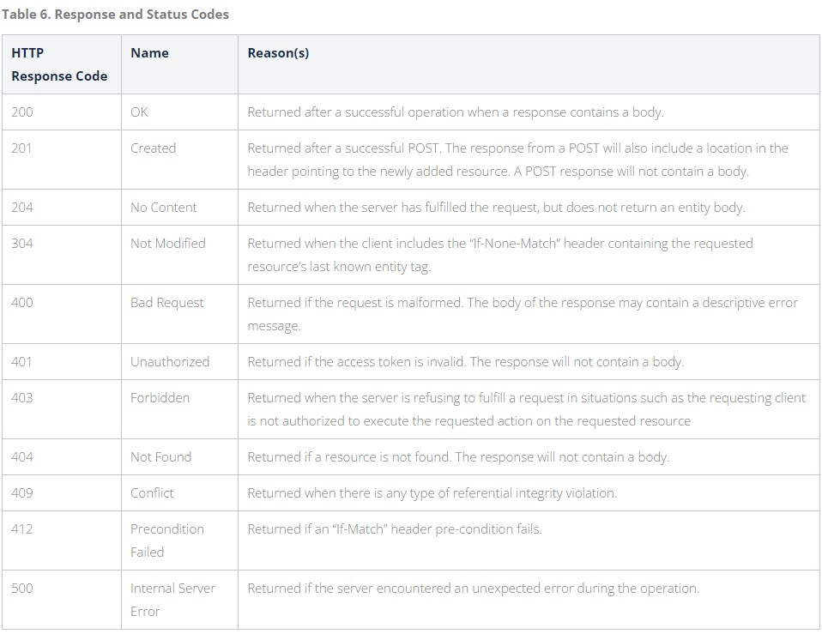
Note that a 403 error is most often caused by a dependency issue. While DEX does internal dependency checks and withholds records from publishing where dependencies are identified, not all situations can be anticipated. There will be cases where DEX attempts to publish a record that passed the internal dependency checks but was still rejected by the API because of a dependency.

Appendix C – Mapping Page Local Code Sources
The eSchoolPlus database sources for the local codes displayed on the Code Set Mapping page are listed below:
  - Academic Subjects – REGTB_DEPARTMENT.CODE; used in Courses, e.g., Math, Language Arts, etc.
  - Attendance Event Categories – ATT_CODE.ATTENDANCE_CODE; map to attendance categories. Only absences and tardies are published. Positive attendance is not published.
  - Behavior Categories – DISC_INCIDENT_CODE.CODE; mapping selects which incident behaviors to publish.
  - Calendar Events – REGTB_DAY_TYPE.CODE; used in Calendar Days, e.g. Instructional, Holiday, etc.
  - Calendar Types – REG_CALENDAR.CALENDAR; grade-based, IEP, student-specific (default).
  - Cohort Types – REG_ACTIVITY_HDR.ACTIVITY_CODE; mapping selects which student activities to publish.
  - Course Level Characteristics – MR_LEVEL_HDR.LEVEL_NUMBER; used in Courses, e.g. Basic, Core, etc.
  - Diploma Types – REGTB_DIPLOMAS.CODE; mapping selects which diploma types to publish.
  - Discipline Action Length Difference Reasons – DISCTB_REASON.CODE
  - Disciplines – DISCTB_OFF_ACTION.CODE; mapping selects which incident actions to publish.
  - Educational Environments – REGTB_ROOM_TYPE.CODE; used in Sections.
  - Entry Codes – REGTB_ENTRY.CODE; used in School Enrollment (StudentSchoolAssociations).
  - Exit Withdraw Codes – REGTB_WITHDRAWAL.CODE; used in School Enrollment.
  - Grade Levels – REG_GRADE.CODE; used in School Enrollment.
  - Grade Types – MR_MARK_TYPES.MARK_TYPE; used in Grades and Transcripts
  - Grading Periods – REG_MP_WEEKS.MARKING_PERIOD; used in Grades.
  - Graduation Plan Codes – REGTB_REQ_GROUP.CODE; used in Graduation Plans and School Enrollment.
  - Homeless Primary Nighttime Residences – REGTB_HOMELESS.CODE; used in Homeless program.
  - Incident Location Types – DISCTB_LOCATION.CODE; used in Discipline Incidents.
  - Languages – REGTB_LANGUAGE.CODE; used in Student Demographics.
  - Program Resources – REG_PROGRAM_SETUP.PROGRAM_ID; map programs to resource for publishing, defaults to generic StudentProgramAssociation.
  - Program Types – REG_PROGRAM_SETUP.PROGRAM_ID; mapping selects which programs to publish.
  - Race Types – REGTB_ETHNICITY.CODE; used in Student Demographics.
  - Relation Types – REGTB_RELATION.CODE; used in Student Contacts.
  - Residency Status Indicators – REGTB_RESIDENCY.CODE; used in School Enrollment.
  - School Categories – REGTB_BLDG_TYPES.CODE; used in Schools.
  - School Food Service Program Services – REGTB_MEAL_STATUS.CODE – used in Student Demographics and School Food Service program.
  - Telephone Number Types – REGTB_PHONE.CODE; used in Student Demographics and Student Contacts
  - Weapons – DISCTB_WEAPONS.CODE – used in Discipline Incidents.
  - Attendance Types – ATT_VIEW_HDR.VIEW_TYPE; select which attendance VIEW_TYPE to publish.
  - GPA Types – MR_GPA_SETUP.GPA_TYPE; select which GPA type to use in Transcripts.
  - Excluded Reporting Terms – used in Grades, mapping optional.

Appendix D – Using Swagger
This appendix is for those interested in the Ed-Fi data model and API; it is not necessary for using DEX Cloud.
- Access Ed-Fi Swagger
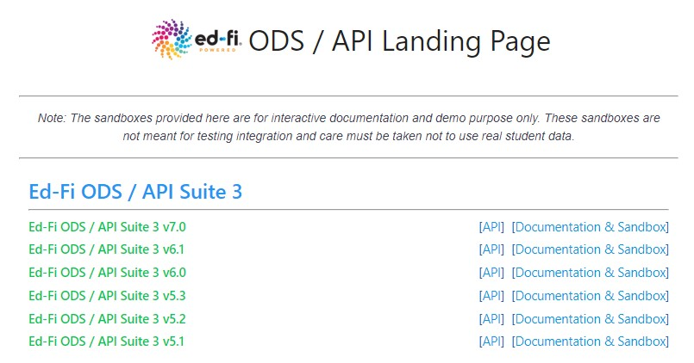
  - Go to http://api.ed-fi.org/ for core Ed-Fi, or other URL if provided for a state implementation.

  - Select ‘Documentation & Sandbox’ at the left side of one of the versions, e.g. API Suite 3 v6.1
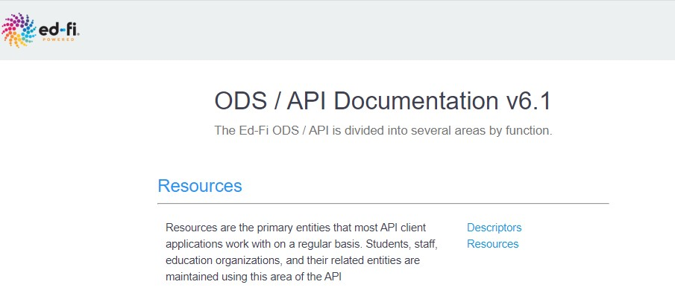
  - The Ed-Fi ODS API is divided into several areas, but this overview is limited to the first area, Resources, which includes Descriptors and Resources.
    - Select ‘Descriptors’ for the list of Descriptors.
    - Select ‘Resources’ for the list of Resources.
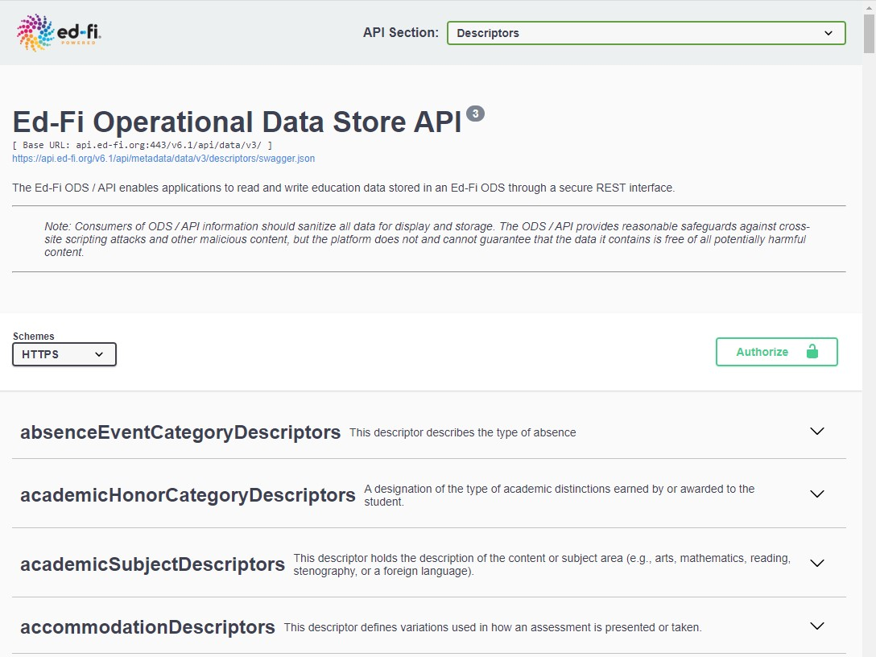
- ‘Descriptors’ has been selected, displaying a list of all the core Ed-Fi descriptors.

  - Descriptor sets are listed alphabetically, along with their descriptions.
    - The full list of descriptors defined in Ed-Fi covers a wide range of applications and can seem overwhelming.
    - DEX Cloud includes the descriptors used in Ed-Fi Certification, plus a few others.

  - Viewing the individual records in a set of descriptors is done using a GET operation. This requires authorization.
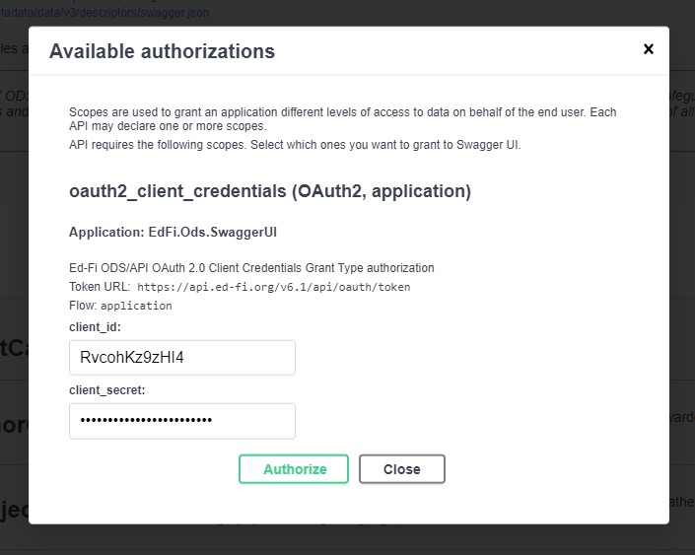
    - Click ‘Authorize’ at the top of the page to display the Authorization dialog box.

    - Default authentication values have been pre-populated into the dialog.
      - State implementations typically do not have default authentication values.
    - If you have a specific key and secret, e.g., for a state implementation, enter those values. Otherwise accept the default values by clicking ‘Authorize’, then close the dialog.
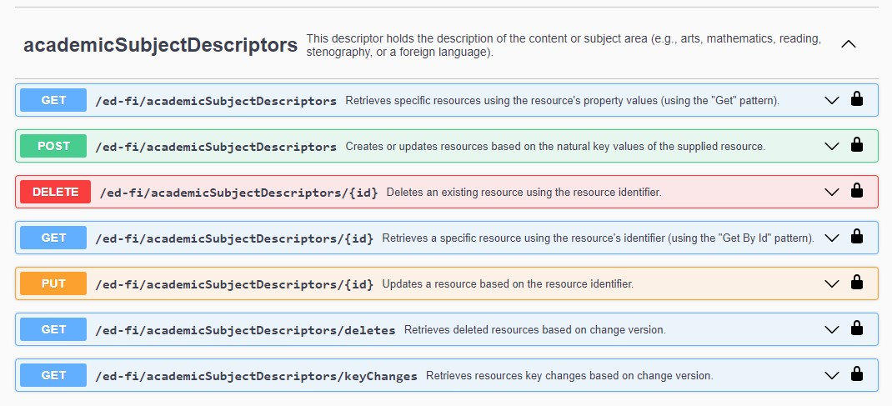
  - Scroll down to the descriptor set you want to view and click on it. A list of operations is displayed.

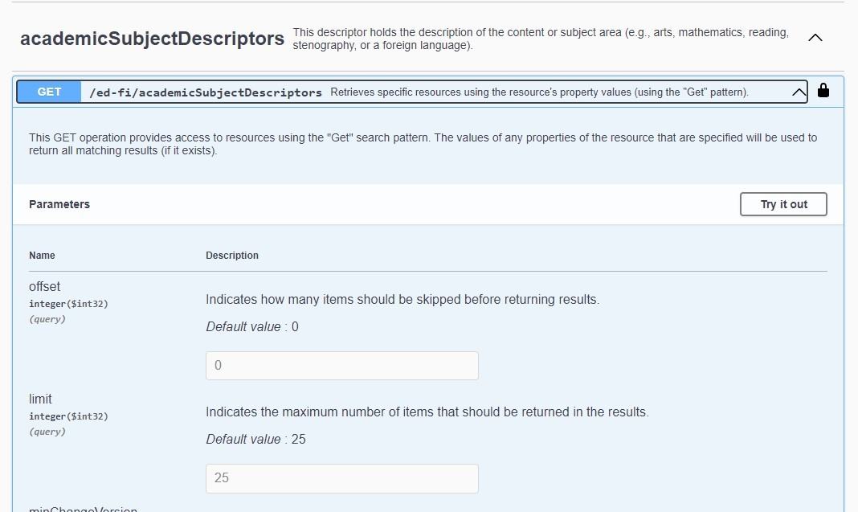
  - Click on the first ‘GET’, at the top of the list to open the GET dialog screen.

  - Accept the default values for Offset and Limit; click ‘Try it out’ at the top left.
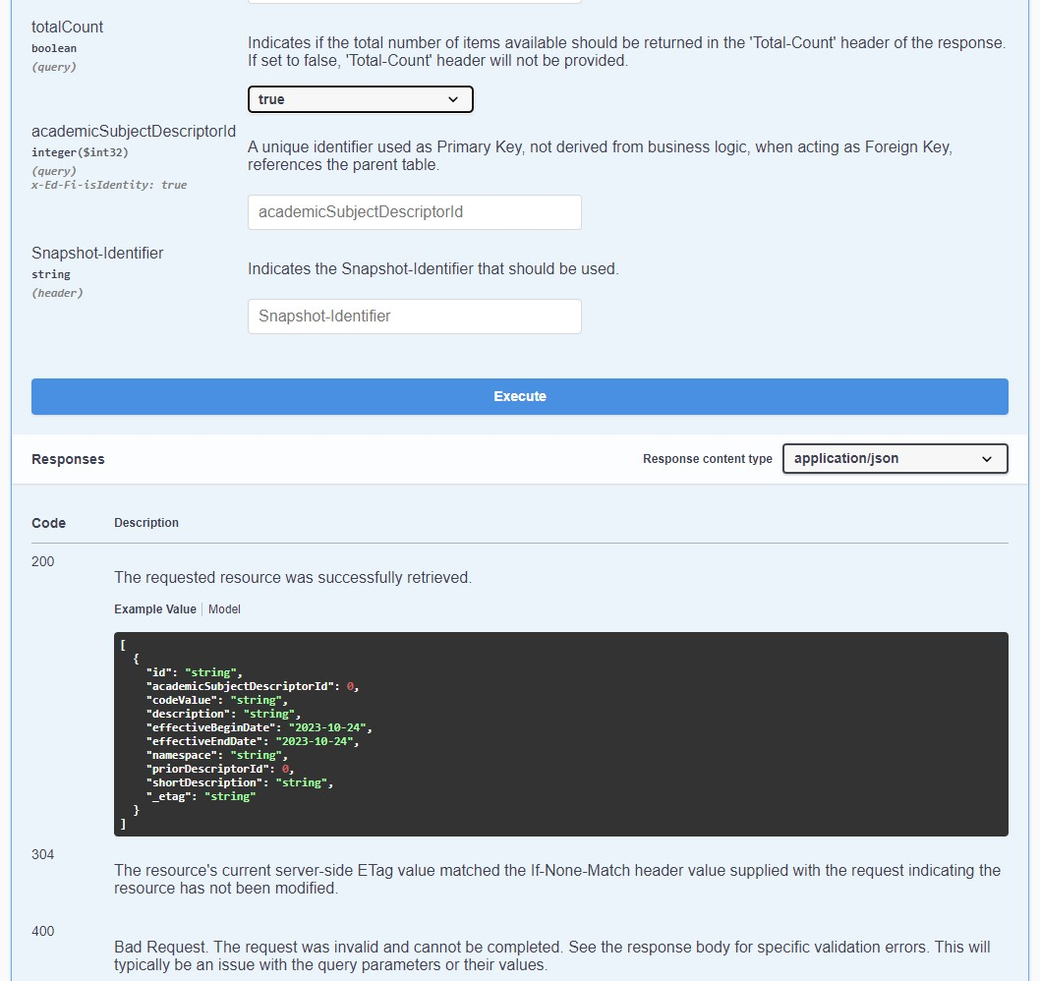
  - A blue ‘Execute’ banner is displayed at the bottom of the GET dialog.

    - Recommendation: set the TotalCount parameter to ‘true’, as in the screenshot.
    - Note that possible responses are displayed below the GET dialog. These are examples only and should not be confused with the actual responses returned after clicking ‘Execute’.
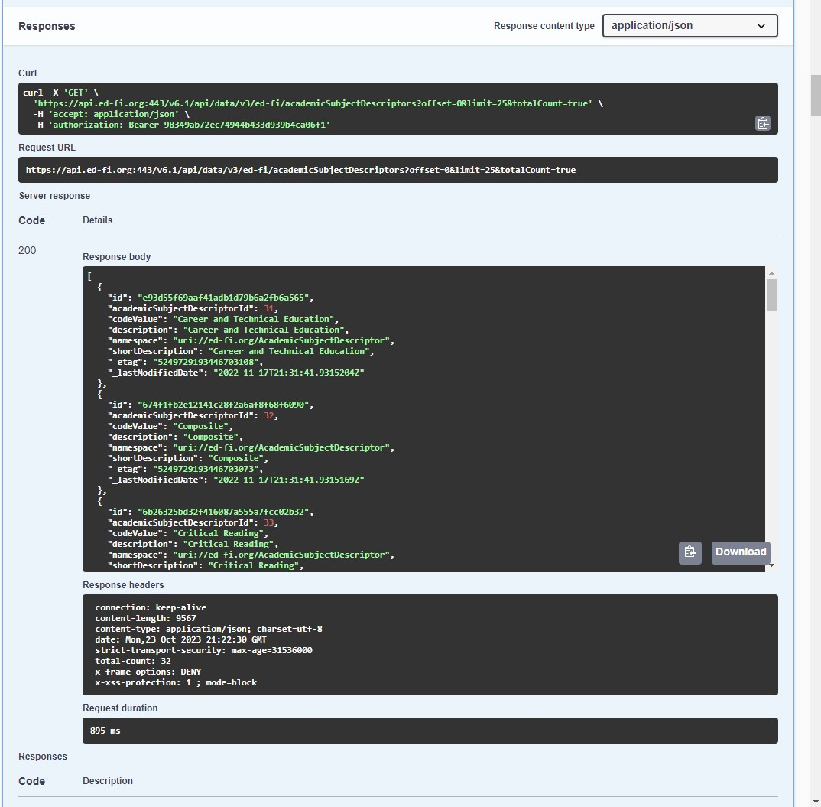
  - Click ‘Execute’ to run the GET operation. Results are displayed below the blue banner and above the sample responses.
    - The response body displays the JSON for the first 25 descriptors in the set.
    - The principal elements are codeValue, description, namespace, and shortDescription.
      - Ed-Fi core descriptors typically use the same value for codeValue, description, and shortDescription.
      - State descriptors typically have a short codeValue and a longer description.
    - In the ‘Response Headers’ section, total-count = 32, so seven descriptors are missing.
      - To see the remaining descriptors, scroll back up into the GET dialog and either change ‘Offset’ to 25 or change ‘Limit’ to 32. Then click ‘Execute’ again.
  - This concludes the Descriptors section of this document.

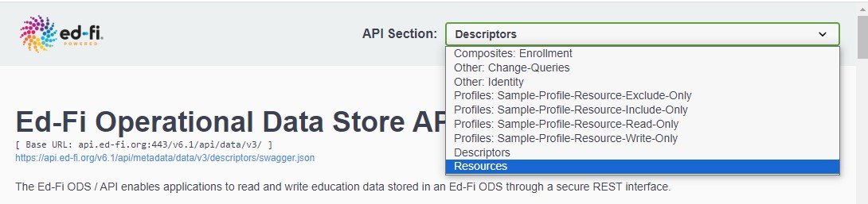
- To change from Descriptors to Resources, scroll to the top of the page and select ‘Resources’ from the API Section drop-down menu.

  - All the core Ed-Fi resources are displayed, alphabetically with descriptions.
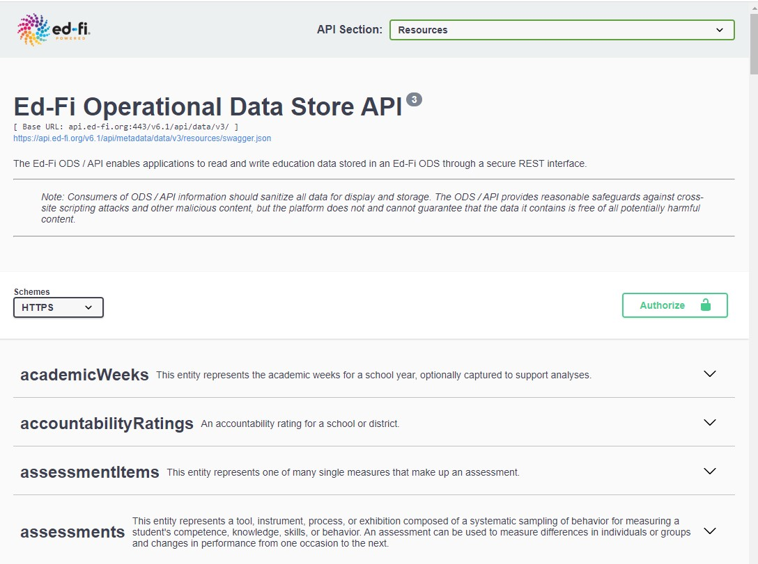
    - As with descriptors, the full list of resources defined in Ed-Fi covers a wide range of applications and can seem overwhelming.
    - DEX Cloud includes the 45 resources listed in Appendix A.
      - These correspond to the resources used in Ed-Fi Certification, plus a few others.
      - State implementations may include additional resources and may not include all resources in Appendix A.
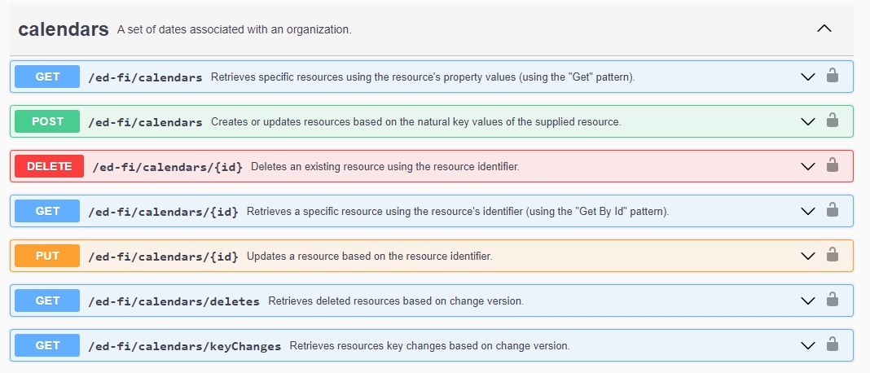
  - Clicking a resource opens a list of available operations.

  - Click POST to view sample JSON and requirements for the resource.
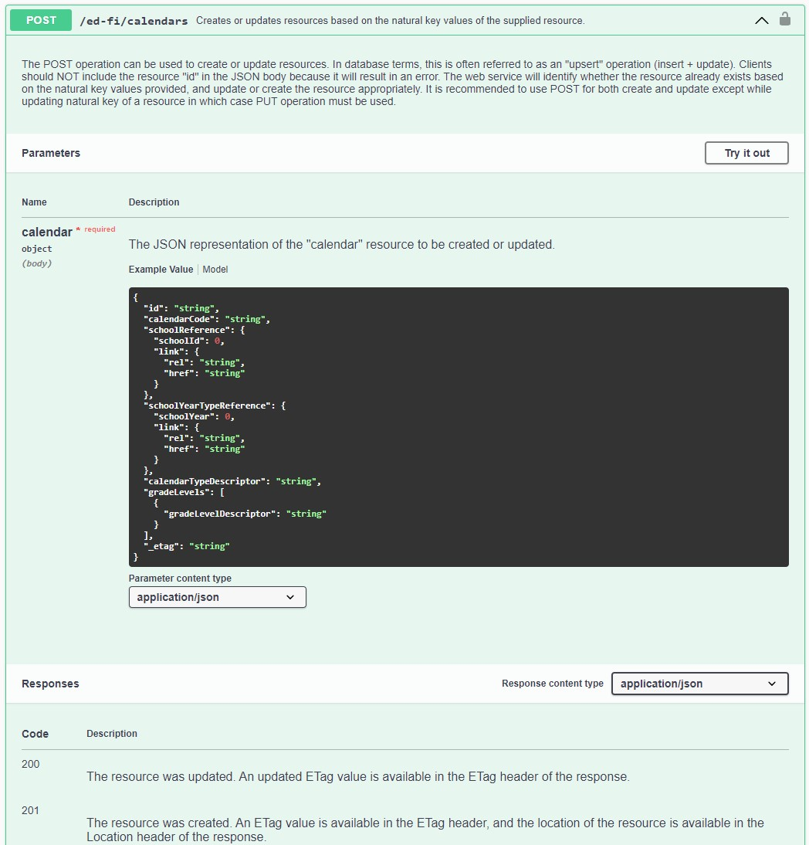
    - The resource opens with JSON structure (‘Example Value’) displayed.

      - The sample JSON does not contain sample data, but does show the format and data types for each element or complex int the resource.
      - Not all elements are required or even allowed in the JSON to be published.
        - The “id” element is not published, but is a GUID returned on successful publishing.
        - The “link” elements and “_etag” element are also not included in the JSON to be published.
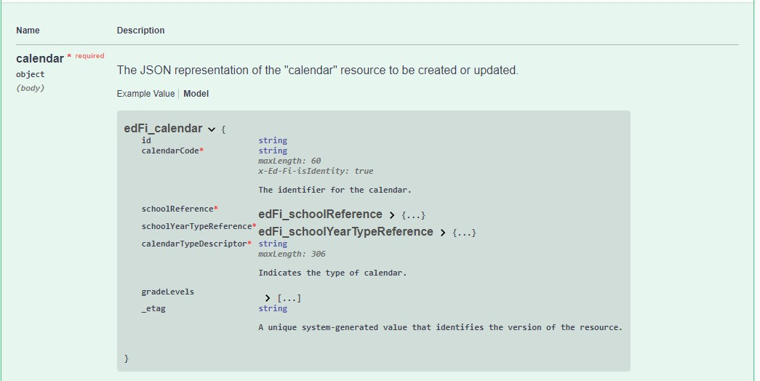
    - Click ‘Model’ above the sample JSON to view the resource structure.

      - The resource elements are displayed with their data type to the right.
      - A red start on the element name indicates the element is required
        - The element may or may not be required for state reporting or other purposes, but it is required to publish the resource.
        - Identifying elements are noted with “x-Ed-Fi-isIdentity: true.”
        - If two records are published with matching Identity elements, the second one will replace the first in the ODS.
      - Boldface font instead of a data type indicates a complex composed of other elements.
        - Click on the boldface to view the composite elements. There may be multiple levels that need to be expanded.
        - If the complex is required, the expanded view will show which elements in it are required.
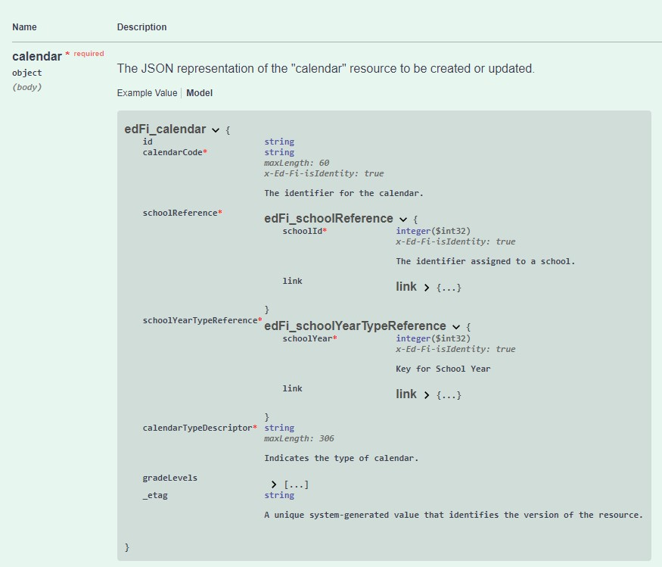
      - In this screenshot, the required complexes have been expanded.

      - Both expanded complexes include a required element that is also an identity element.
        - The complete identity set for the Calendar resource includes three elements:
          - calendarCode
          - schoolId
          - schoolyear
        - Any references to Calendar in other resources will need to include the three identity elements and no others.
          - Other elements – even if required in the Calendars resource – would not be accepted in a reference to a Calendar record from another resource.
        - Note that the boldface ‘edFi_schoolReference’ and ‘edFi_schoolYearTypeReference’ are not included in the JSON, only the actual elements.
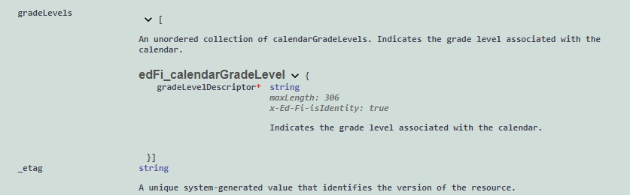
      - GradeLevels is an array, which is a collection of one or more values. It has been expanded in this screenshot.

        - Even though gradeLevels is not itself required, if it is included at all then it has a required element, with is also an identity element.
        - The gradeLevelDescriptor is not an identify element for the Calendar record, but it is an identity element for the gradeLevels within the array.
        - Identity elements within an array cannot be identity elements for the resource, even if the array is required.
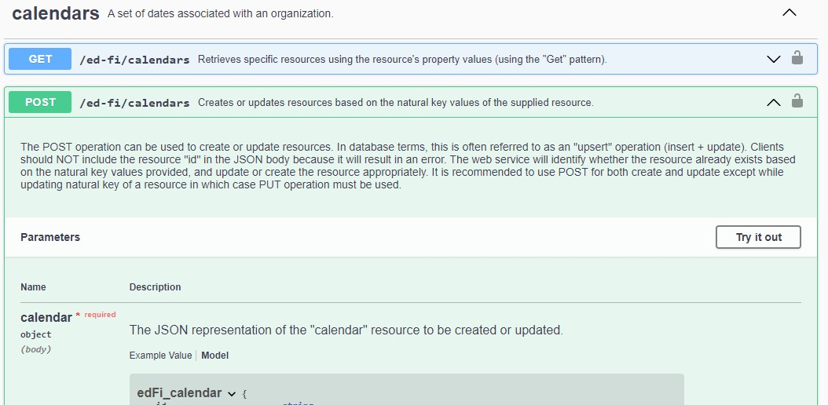
      - JSON for publishing can be tested by selecting ‘Try it out’ at the top of the POST section.

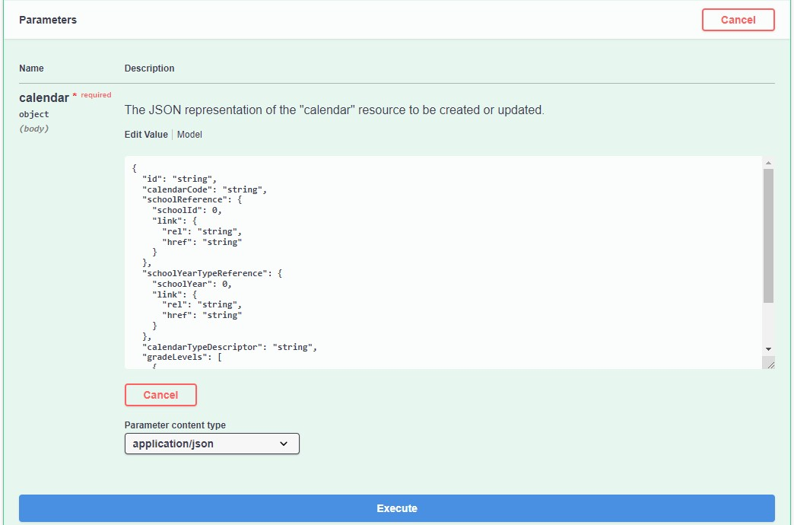
        - A box for entering JSON is opened with sample JSON. Replace sample with your JSON.

        - You will need to authorize before executing, same as for GET with descriptors.
        - After authorizing and entering your JSON, click ‘Execute’.
        - The API will return either a successful 200 or 201 code, or it will return an error code and message.
        - After receiving a success code, you can follow with a GET to verify that what is returned to you is what you expected.

