Dashboard Proof of Concept

Sizing Estimate – White Paper

Prepared for Ed-Fi Alliance

July 24, 2020

Overview
The Dashboard Proof of Concept (POC) project is a six-week project funded by the Ed-Fi Alliance to address a number of architectural issues related to the ongoing advancement of the Ed-Fi Technical Suite. The following are the goals of the project.
- Demonstrate that a technical modernization of the Ed-Fi Dashboard UI is viable.
- Provide a handoff to a subsequent project that will explore how to replace the existing Dashboard ETL/data pipeline and security mechanisms with an approach that is integrated with the Analytics Middle Tier.
- Provide a framework for estimating the cost of modernizing the entire Ed-Fi Dashboard.

Items one and two have been delivered and are available from the Ed-Fi Exchange.
This white paper addresses item three, estimating the cost for modernizing the entire Ed-Fi Dashboard.
Section 2 explains the methodology of this estimation.
Section 3 presents the estimate.
Appendix A has a diagram of the POC as delivered for reference.

Methodology
Given the funding and time constraints, there were a number of important considerations related to full implementation of the existing Ed-Fi Dashboard that were placed out of scope for the POC. The following user interface issues were out of scope.
- Authentication of the user at the UI
- Establishing data authorization for the user
- Management and presentation of student/staff images
- Creation of a district management page for district administrators
- Management of the watch list or dynamic list management
- Management of export functions for various data sets within the user interface

While these important functions were out of scope for the POC, the estimates do include a rough estimate of scope required to address these items. It is important to remember that the authentication and authorization functionality is extremely variable and highly dependent upon the architecture and system control functions being employed by a user interface integration project.
The specific estimates for the remaining user interface elements were constructed using the following approach.
- The hour estimates for work done on the project were broken into four areas of effort.
  - Research of tools/environment and environment setup
  - Data access methods/queries for the GRAPHQL/API
  - React component research and integration for UI tool extensions
  - UI development within React framework
- Reference estimates were done for the three user interface screens in the POC.
  - Student Information page
  - Student List page (teacher)
  - Column control for Student List page
- A complete outline of the existing page structure was created for student/school/district.
- The reference estimates were used to estimate the sizing of each page separately by comparison of the data access, expected tool component, and development loads.

Finally, it must be stressed that the estimates provided are intended to represent the hours required solely for development of a re-implemented user interface. They do not include hours for the standard components of a significant project such as project management or testing since these are very dependent on the practices of the implementing organization.

Ed-Fi Dashboard Full Estimate
The full dashboard re-implementation estimate is summarized here, then the details of each of the major component areas (Student Pages, School Pages, and District Pages) are provided in the following subsections.
For the re-implementation of the core Ed-Fi dashboards, the three major component area hour estimates are summarized in the following table.
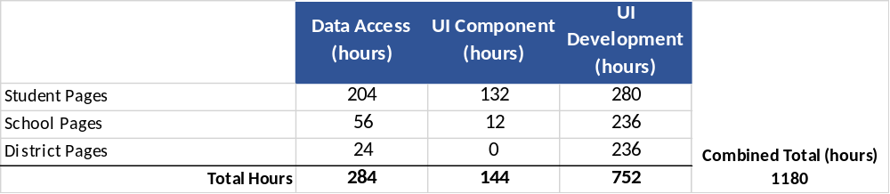
This represents just under eight person-months of software engineering effort to design and build the data interface using the GRAPHQL API along with the selection and use of user interface components to develop the replacement visualizations.
In addition to this, we estimate a re-implementation would require the following functions and visual components, which would add another four to five person-months of engineering effort.
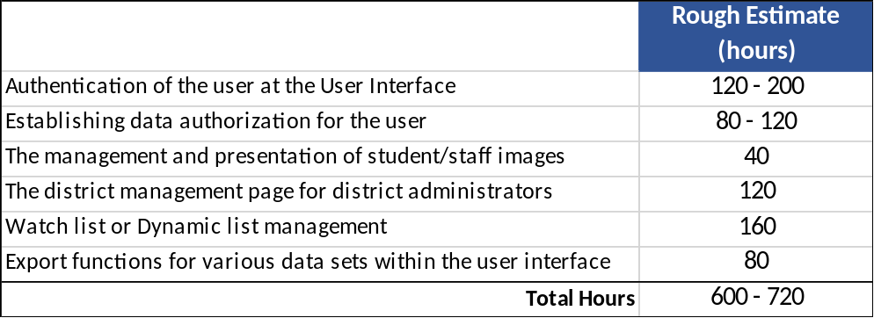
Finally, a re-implementation using a different architecture from our POC would need to include hours to implement the data access and visualizations included in our POC. This represents slightly more than two person-months of engineering distributed as data access (180 hours), UI component (50 hours), UI development (150 hours).
Details for the student, teacher, and district pages are in the following sections. Note that for the Data Access and UI Component columns, the time required to research and implement the data access or visual component is only included for the first instance where it is needed. Subsequent use assumes the component is available and only development is needed specific to that data element or visualization. This accounts for the large number of zeros in those columns.

Student Pages Estimates
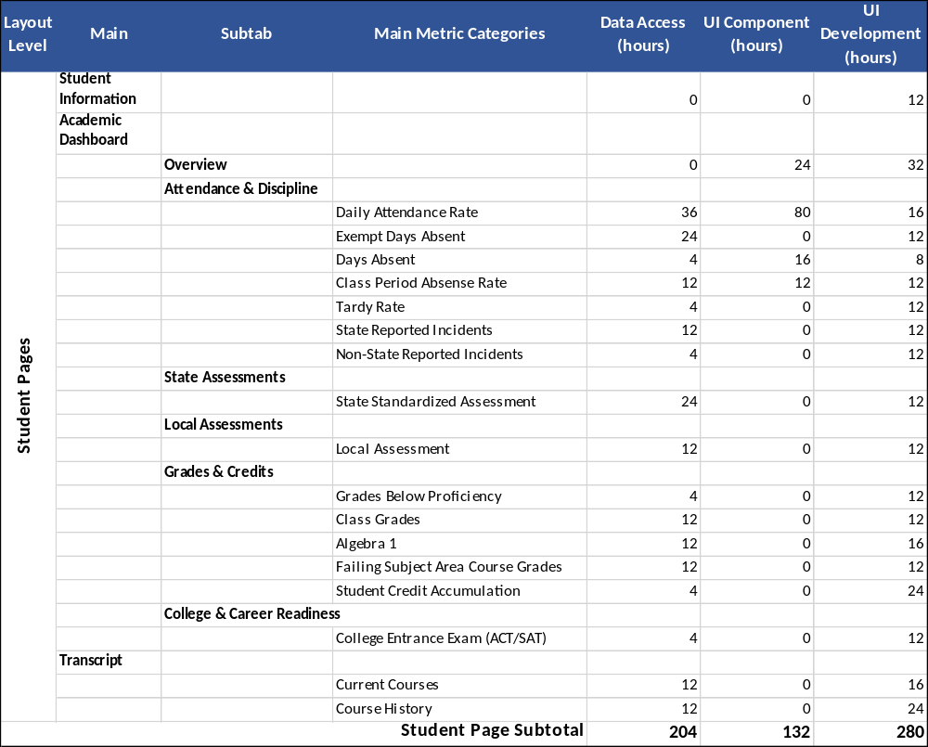

School Pages Estimates
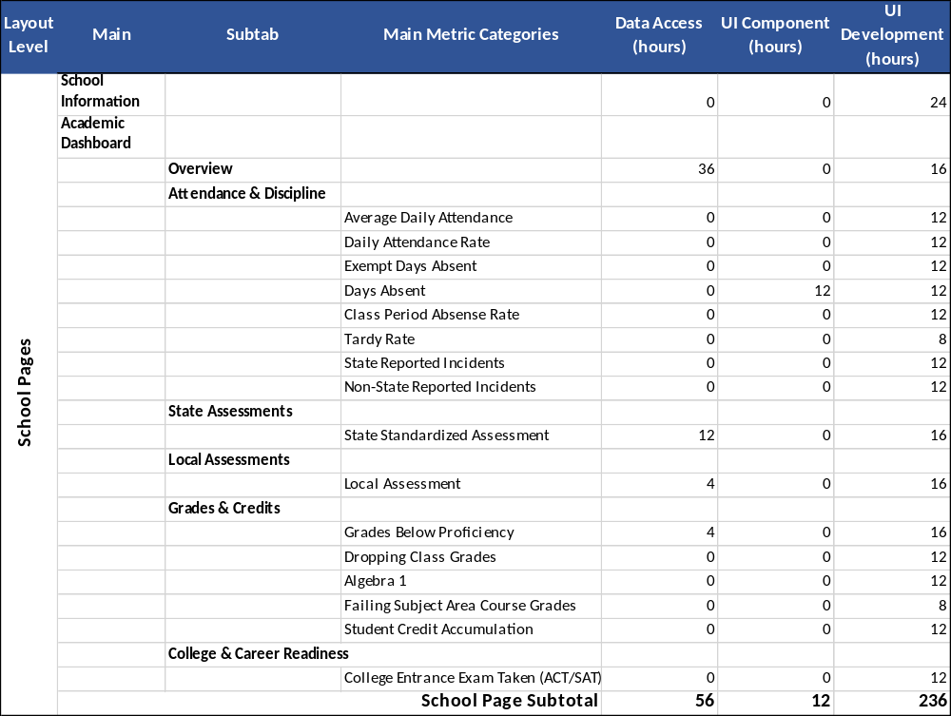

District Pages Estimate
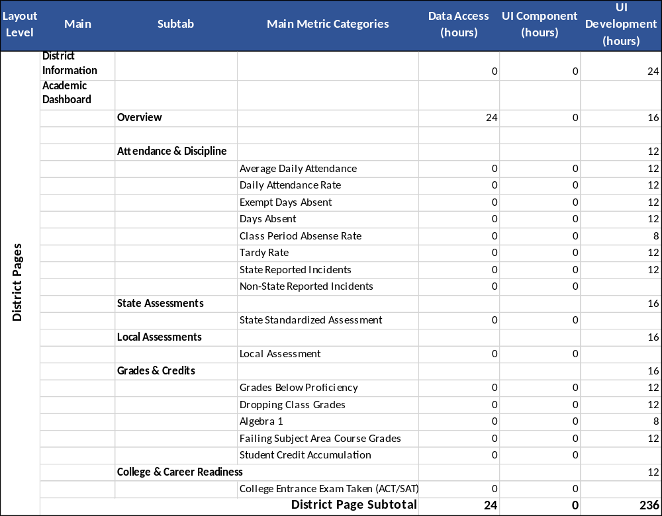

Appendix A
This architecture was developed to re-implement the student information page, student list teacher page, and column control for student list page. It was used to establish the baseline timing on which the estimates are based.
