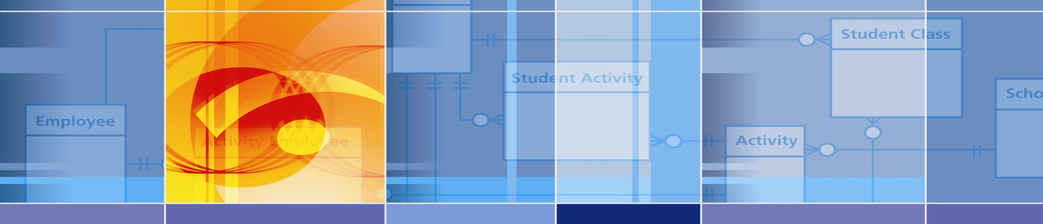

Dashboard Proof of Concept

Design and Operations Guide

Prepared for Ed-Fi Alliance

July 20,2020

Introduction and Overview
The Dashboard Proof of Concept (POC) project is intended to address a number of architectural issues related to the ongoing advancement of the Ed-Fi Technical Suite. The following are the goals of the project.
- Demonstrate that a technical modernization of the Ed-Fi Dashboard UI is viable.
- Provide a framework for estimating the cost of modernizing the entire Ed-Fi Dashboard.
- Provide a handoff to a subsequent project that will explore how to replace the existing Dashboard ETL/data pipeline and security mechanisms with an approach that is integrated with the Analytics Middle Tier.
The agreed approach is to reimplement the student list page and the student demographic page to demonstrate these goals.
The architecture for the Dashboard POC is presented on the following page.
The architecture consists of a GRAPHQL API which can connect to a data source and is configured to provide JSON communications through the query endpoint. The approach can be used for connection to any type database and be configured to respond to any supportable data query. The POC demonstration provided connects to the Ed-Fi Glendale Dashboard Data Store (DDS) and responds to queries for metrics schema, student data, metric data, and student profile data.
The GRAPHQL API includes an API playground to allow ad-hoc queries into the API to facilitate testing of the API and to support UI design work. Intended for developers, it allows a web user to submit a query and example the resulting response.
The React application queries data from the API and implements the user interface enhanced prototype to demonstrate a more modern approach to visualize the student list page, the student profile page, and includes a column configuration tool to adjust the visible columns on the student list page. The column configuration state is saved locally in browser storage and is thus not persistent between sessions.
The following sections detail the procedures to build and setup the POC application, the details of the API, and additional details on the React application and user interface.
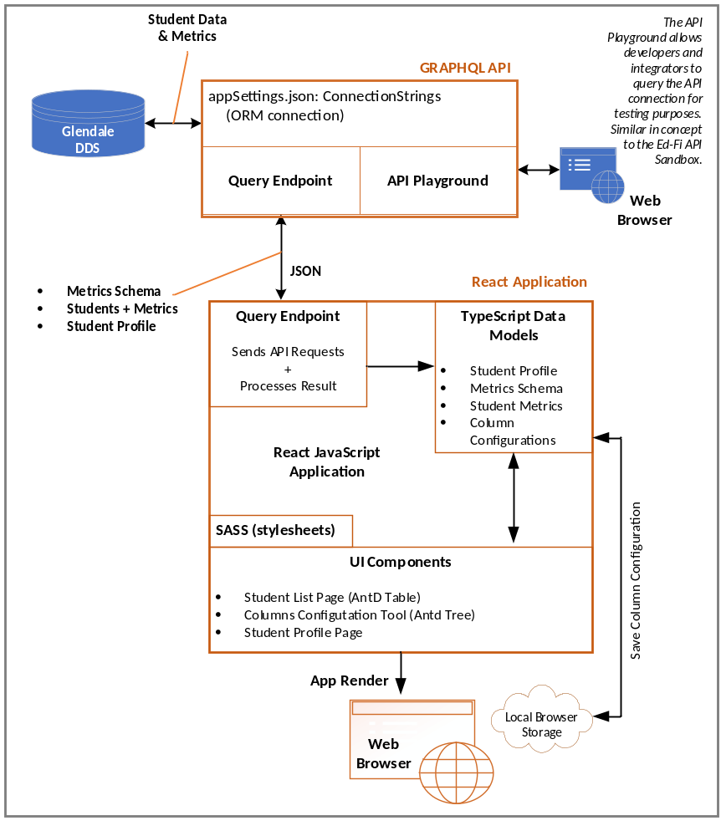
Dashboard Proof of Concept Architecture

Dashboard POC Build and Setup Procedures

Environment Requirements
Before building and deploying the Dashboard POC the user must first meet the following system requirements to build and run the system components.

Requirements to build the React app
- Node.js (https://nodejs.org/en/)

Requirements to build the API
- Net Core 3.1 SDK
- Visual Studio 2019

Requirements for deploying on IIS
- IIS URL Rewrite Module 2.1
- ASP Net Core Module V2

Build Process
Follow these procedures to locally build the applications.

Steps to build and run the UI locally

- Open Powershell and go to folder edfi-visualization-poc/UI
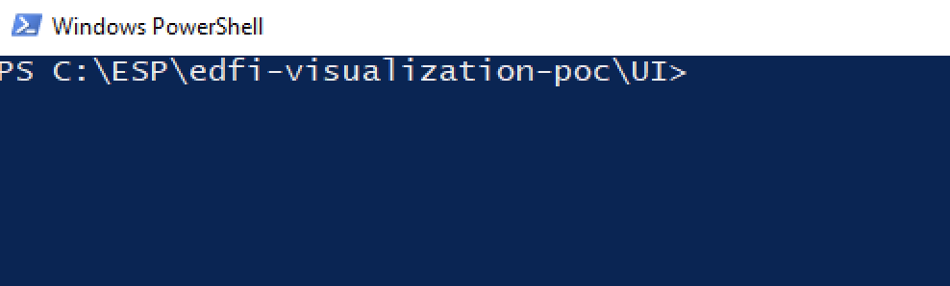
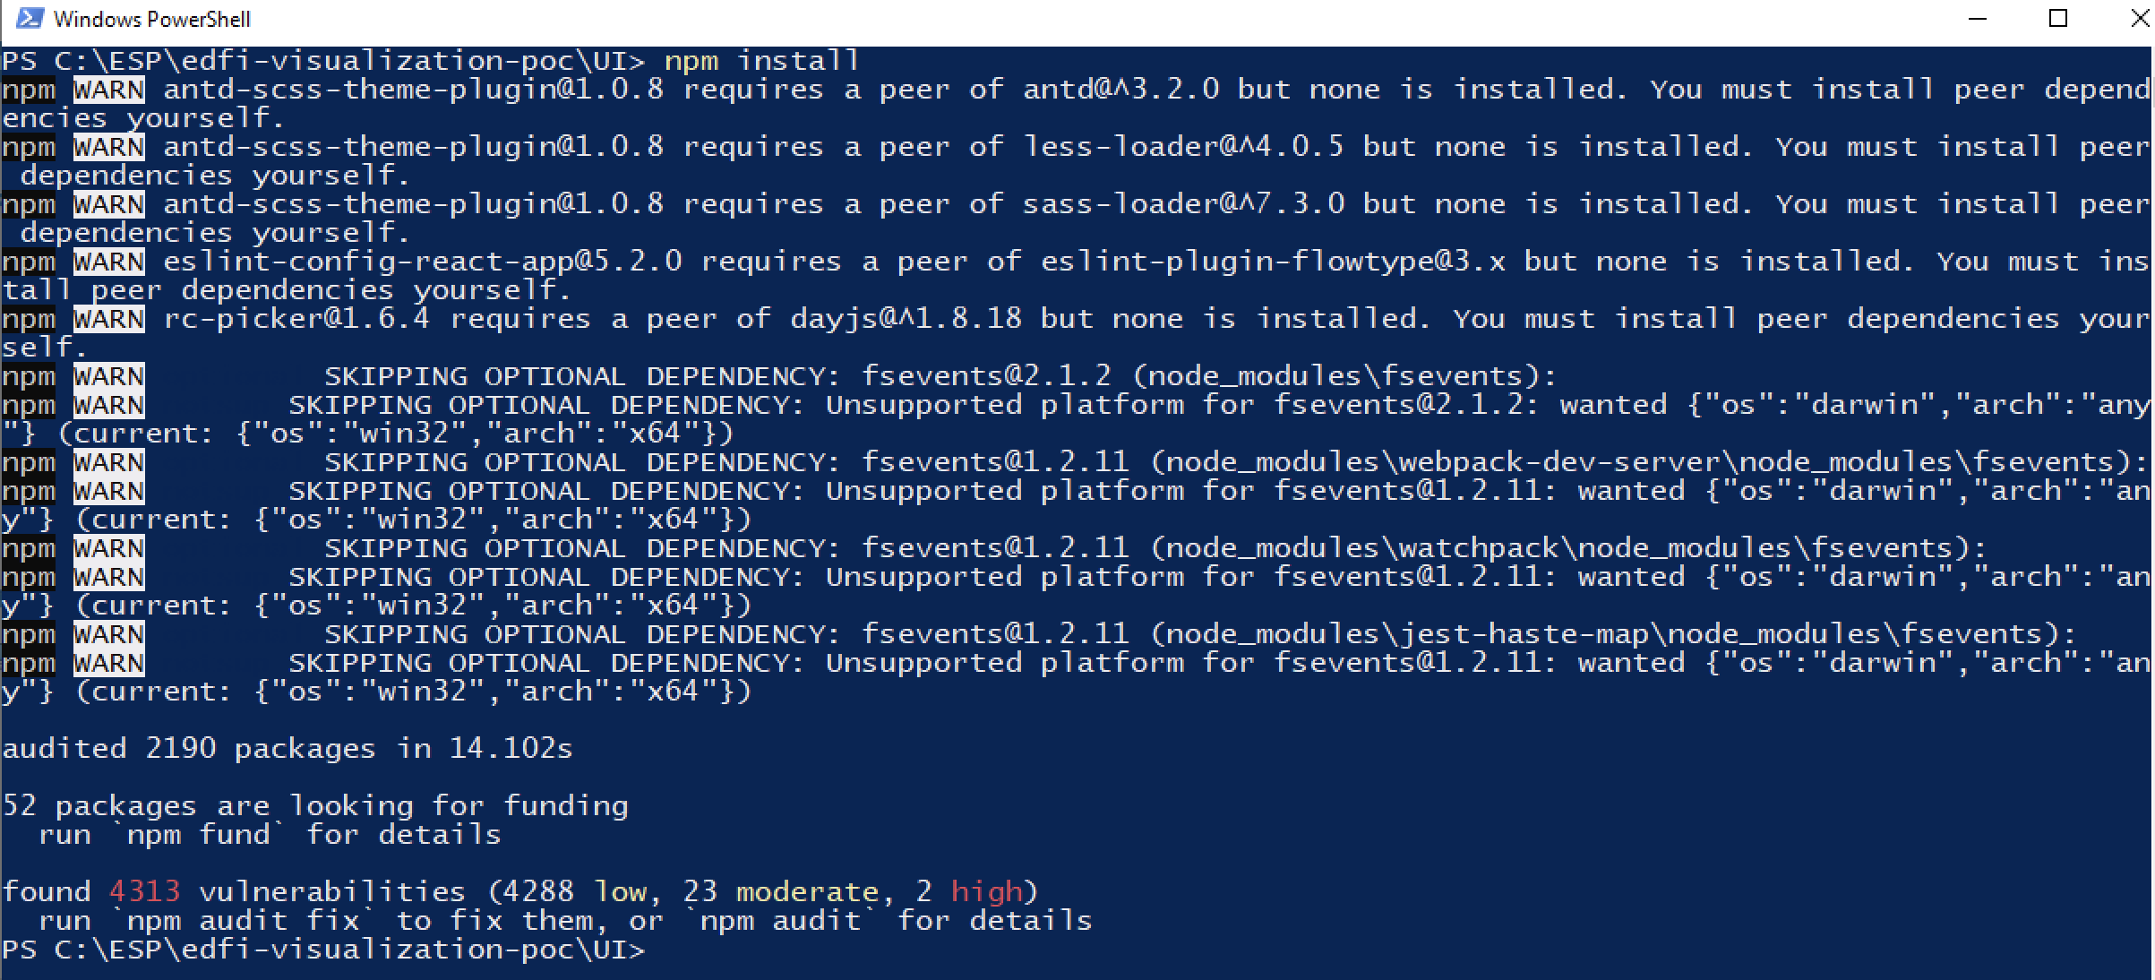
- Execute npm install

This will install all needed packages for the UI app to be executed

- Execute npm run start
This will start the development server where the UI app will be executed and open the UI on the default browser
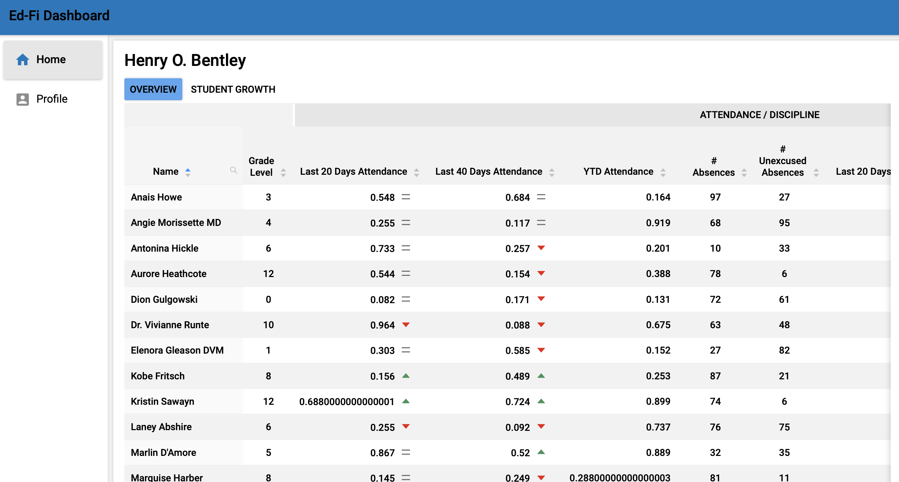

Steps to build and run the API locally
  - Open EdFiVisualizationPOC.sln solution

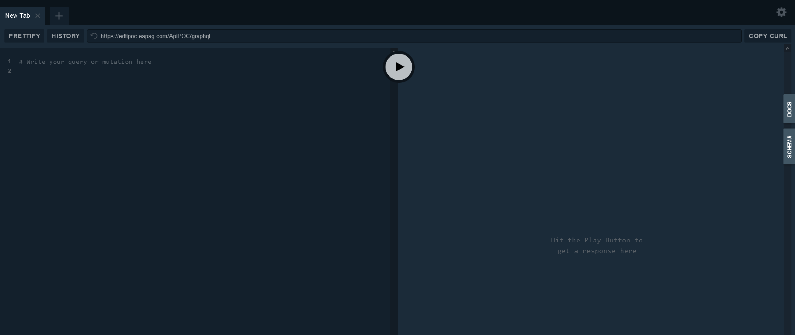
  - Set GraphQLApi as Startup Project

  - Start the project (Press F5)

Application Programming Interface (API)
A more generalize view of the GRAPHQL API is presented below.
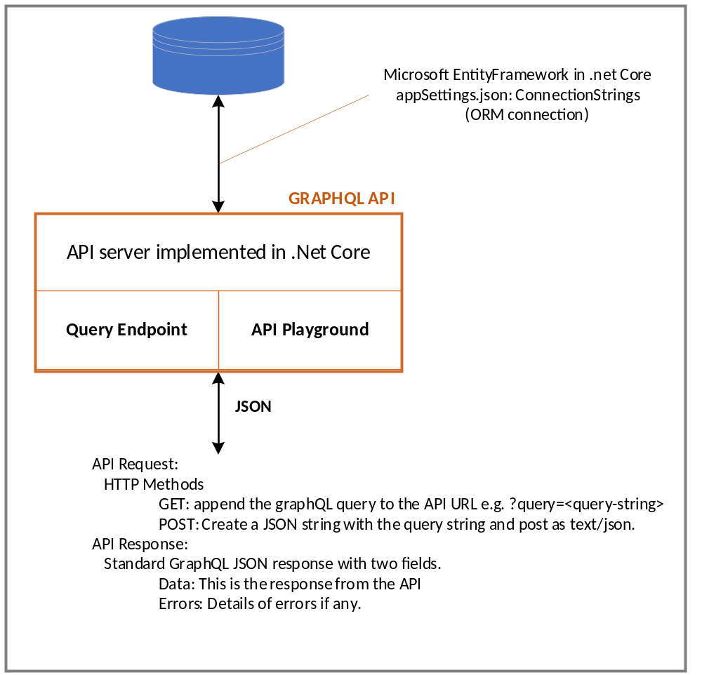

The API can connect to any MSSQL data source and implements an ORM connection using the Microsoft EntityFramework in .Net core. The server is implemented in .Net core. It provides a query endpoint and playground connection supporting a request/response interface. It accepts GET/POST request and supplies responses to provide data formatted into data and error fields.

The mechanism is extensible, and currently includes three queries.
- metricMetadata: [MetricMetadataNodeType]
  - Querying for the metricMetadata returns an Array of MetricMetadataNodeType.
- student(studentUsi:ID): StudentInformationType
  - Provides ability to query a particular student. Returns an instance of StudentInformationType for the given student ID or NULL.
- students(schoolId: ID, offset: int, limit: int): [StudentInformationType]
  - Provides ability to query List of Students given the School ID. The offset and limit parameters are nullable and default to 0 and 100 respectively. The query returns an Array of StudentInformationType objects.

Appendix A lists the Schema and has some examples of the use and expected responses of several queries.

The following page has a screenshot of a query/response using the API Playground.

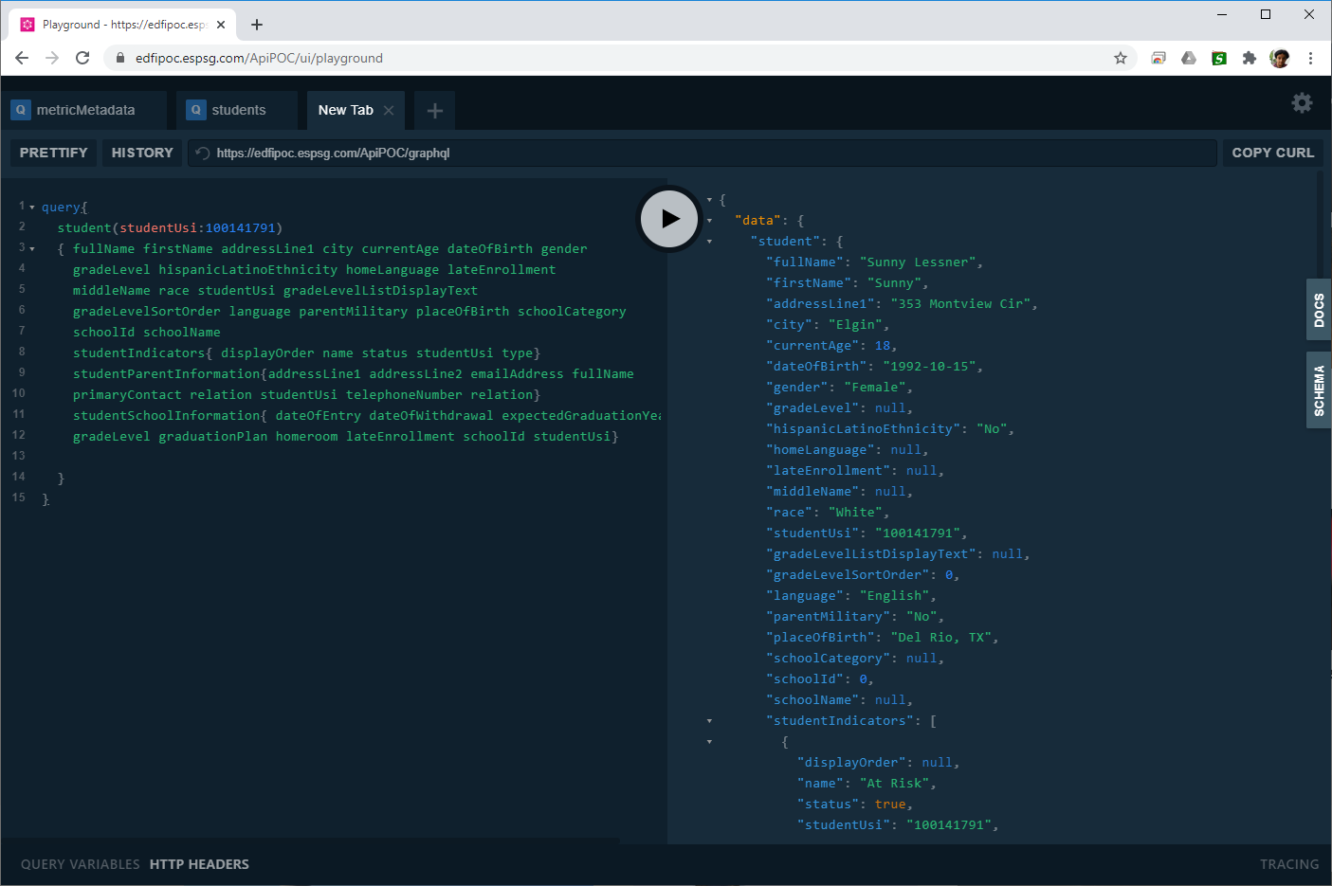

Dashboard POC User Interface
The POC interface has a navigation bar and component area. Shown below is the student list page. The page has features expected from modern visual frameworks, including auto-resizing and support for a wide range of display devices. The new layout is streamlined but retains many of the features of the existing Ed-Fi dashboard student list page. It allows searching of students and sorting bi-directionally on any column. Clicking on student takes you to the student page (next page).

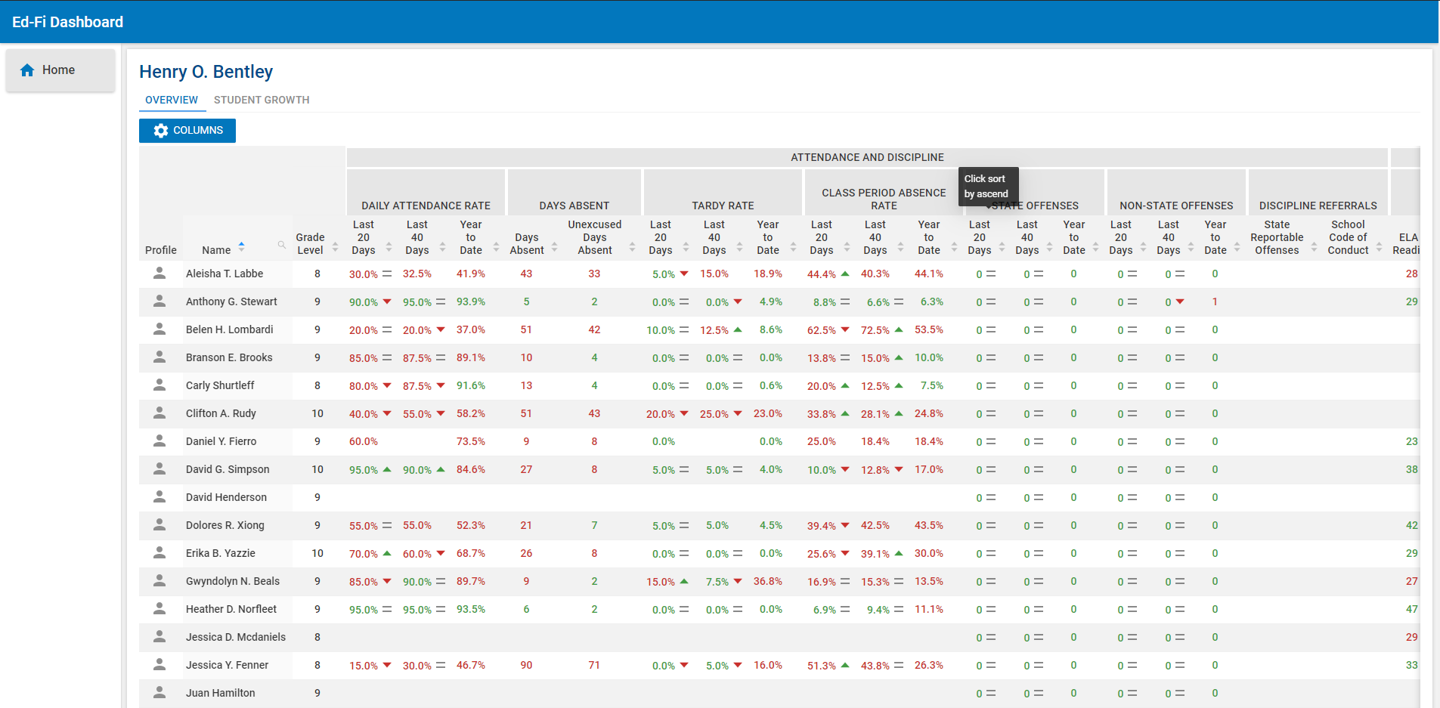

The student page presents the same demographic data as the existing Ed-Fi dashboard, but automatically determines the best fit for the data.
This is most easily seen if we compare the web page visual to the visual as displayed on a phone.
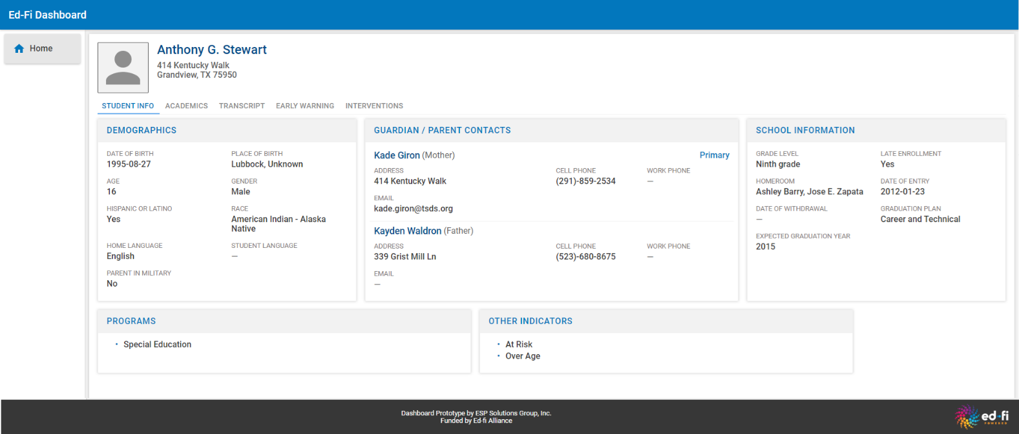
Web Page View:

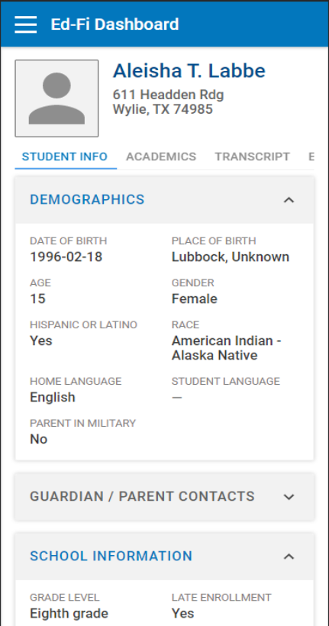
Phone View:

The Dashboard POC can resize and determine the best layout for available screen real estate. When needed, the layout automatically provides expand/contract controls as seen here for the GUARDIAN/PARENT CONTACT section of the visualization.

The Dashboard POC includes a table column configuration control tool to allow the user to include or exclude columns. The column controls are presented hierarchically so that individual columns or collections of columns under the same heading can be included or excluded. Because the Dashboard POC was intentionally implemented without user authentication controls – to limit scope of the project – the control settings are stored locally in the browser. An implementation with authentication would want to make these setting persist for the user.

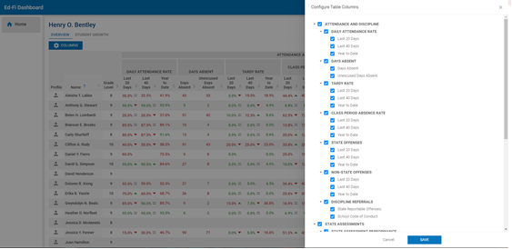

APPENDIX A – API Schema and Sample Queries

Schema

Schema
schema {
query: AppQuery
}

Type AppQuery
type AppQuery {
metricMetadata(domainEntityTypeId: ID = null): [MetricMetadataNodeType]
student(studentUsi: ID = null): StudentInformationType
students(
schoolId: ID = null
offset: ID = null
limit: ID = null
): [StudentInformationType]
}

Type StudentInformationType
type StudentInformationType {
addressLine1: String!
addressLine2: String
addressLine3: String
city: String!
currentAge: Int
dateOfBirth: Date!
emailAddress: String
firstName: String!
fullName: String!
gender: String!
gradeLevel: String
gradeLevelListDisplayText: String
gradeLevelSortOrder: Int
hispanicLatinoEthnicity: String
homeLanguage: String
language: String
lastSurname: String!
lateEnrollment: String
metrics(
schoolId: ID = null
metricId: ID = null
metricIds: [Int] = null
): [StudentMetricType]
middleName: String
parentMilitary: String
placeOfBirth: String
race: String
schoolCategory: String
schoolId: Int
schoolName: String
state: String!
studentIndicators: [StudentIndicatorType]
studentParentInformation: [StudentParentInformationType]
studentSchoolInformation: [StudentSchoolInformationType]
studentUsi: ID
telephoneNumber: String
zipCode: String!
}

Type StudentIndicatorType
type StudentIndicatorType {
displayOrder: Int
name: String!
status: Boolean!
studentUsi: ID
type: String!
}

Type StudentSchoolInformationType
type StudentSchoolInformationType {
dateOfEntry: Date
dateOfWithdrawal: Date
expectedGraduationYear: String
gradeLevel: String!
graduationPlan: String
homeroom: String
lateEnrollment: String
schoolId: Int!
studentUsi: ID
}

Type StudentParentInformationType
type StudentParentInformationType {
addressLine1: String
addressLine2: String
addressLine3: String
emailAddress: String
fullName: String!
primaryContact: Boolean
relation: String
studentUsi: ID
telephoneNumber: String
workTelephoneNumber: String
}

Type StudentMetricType
type StudentMetricType {
id: Int!
name: String!
parentId: Int
parentName: String
state: String
studentUsi: ID
trendDirection: Int
type: String!
value: String
}

Type MetricMetadataNodeType
type MetricMetadataNodeType {
children: [MetricMetadataNodeType]
description: String
displayName: String!
displayOrder: Int!
domainEntityType: String!
domainEntityTypeId: Int
enabled: Boolean!
metricId: Int!
metricTypeId: Int!
name: String!
shortName: String!
tooltip: String
url: String!
}

Queries

Student details with individual Metrics
query{
students(schoolId:867530011,offset:100,limit:5)
{
fullName firstName addressLine1 city currentAge dateOfBirth gender gradeLevel hispanicLatinoEthnicity homeLanguage lateEnrollment middleName race studentUsi gradeLevelListDisplayText gradeLevelSortOrder language parentMilitary placeOfBirth schoolCategory schoolId schoolName
studentIndicators
{
displayOrder name status studentUsi type
}
studentParentInformation
{
addressLine1 addressLine2 emailAddress fullName primaryContact relation studentUsi telephoneNumber relation
}
studentSchoolInformation
{
dateOfEntry dateOfWithdrawal expectedGraduationYear gradeLevel graduationPlan homeroom lateEnrollment schoolId studentUsi
}
metrics(schoolId:867530011,metricIds:[3,4,5])
{
Name parentId parentName trendDirection state value
}
}
}

Student details with Metric subtree.
query{
students(schoolId:867530011,offset:100,limit:5)
{
fullName firstName addressLine1 city currentAge dateOfBirth gender gradeLevel hispanicLatinoEthnicity homeLanguage lateEnrollment middleName race studentUsi gradeLevelListDisplayText gradeLevelSortOrder language parentMilitary placeOfBirth schoolCategory schoolId schoolName
studentIndicators
{
displayOrder name status studentUsi type
}
studentParentInformation
{
addressLine1 addressLine2 emailAddress fullName primaryContact relation studentUsi telephoneNumber relation
}
studentSchoolInformation
{
dateOfEntry dateOfWithdrawal expectedGraduationYear gradeLevel graduationPlan homeroom lateEnrollment schoolId studentUsi
}
metrics(schoolId:867530011,metricId:65)
{
Name parentId parentName trendDirection state value
}
}
}

Metric Metadata Tree
metricMetadata{
description displayName domainEntityType displayOrder metricId name url
children{
description displayName domainEntityType displayOrder metricId name url
children{
description displayName domainEntityType displayOrder metricId name url
children{
description displayName domainEntityType displayOrder
metricId name url
children{
description displayName domainEntityType displayOrder metricId name url
children{
description displayName domainEntityType displayOrder metricId name url
children{
description displayName domainEntityType displayOrder metricId name url
}
}
}
}
}
}
}
}

Student details for the student profile page.
query{
student(studentUsi:100141791)
{
fullName firstName addressLine1 city currentAge dateOfBirth gender gradeLevel hispanicLatinoEthnicity homeLanguage lateEnrollment middleName race studentUsi gradeLevelListDisplayText gradeLevelSortOrder language parentMilitary placeOfBirth schoolCategory schoolId schoolName
studentIndicators
{
displayOrder name status studentUsi type
}
studentParentInformation
{
addressLine1 addressLine2 emailAddress fullName primaryContact relation studentUsi telephoneNumber relation
}
studentSchoolInformation
{
dateOfEntry dateOfWithdrawal expectedGraduationYear gradeLevel graduationPlan homeroom lateEnrollment schoolId studentUsi
}

}
}

